Capstone Trading Advisors Inc. 830-249-7007

Tuesday October 9, 2001

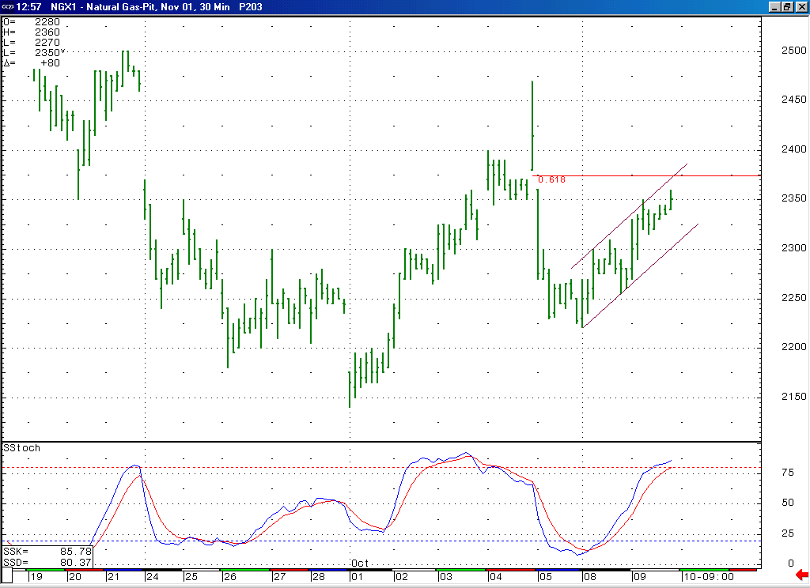
The market has chopped its way higher here for a couple of days. This rise appears to be of a corrective nature to us (choppy and contained within the channel shown here). If this rise is a minor correction, as we believe is likely, then we would expect it to encounter good near term resistance here at the 61.8% retrace of its previous drop (which is located at 2.375).
Also, if this recent pop up is corrective, you would expect the fact that the market is now moving into a near term overbought condition (as witnessed by this 14-bar stochastic) to soon lead to the conclusion of this move.

The information herein is believed to be reliable, however Capstone Trading Advisors Inc. does not warrant its completeness or accuracy. The opinions and estimates contained constitute our judgment and are subject to change without notice. Past performance is not indicative of future results. The information contained herein is not intended as an offer or solicitation for the purchase or sale of any financial instrument or commodities. Chart provided with permission from CQG Inc.

