Capstone Trading Advisors Inc. 830-249-7007

Nat Gas Summary for 10/9/01: The market recently turned down sharply with its resistance in the 2.48 to 2.50 area still intact. With this occurrence, we continue at this time to look for the market to move lower in the near term, with a minimum target of new lows (below 2.14). While this current decline began in a very quick fashion, we would expect the remainder of this anticipated drop to new lows to occur in a more orderly fashion. If the market does get below the 2.14 low in the days ahead, we would look for its next downside targets to lie in the 2.03 and 1.91 areas at that point.

Support: 2.22 2.14 2.03 1.91 Resistance: 2.315 2.375 2.47 2.50-2.53 2.59

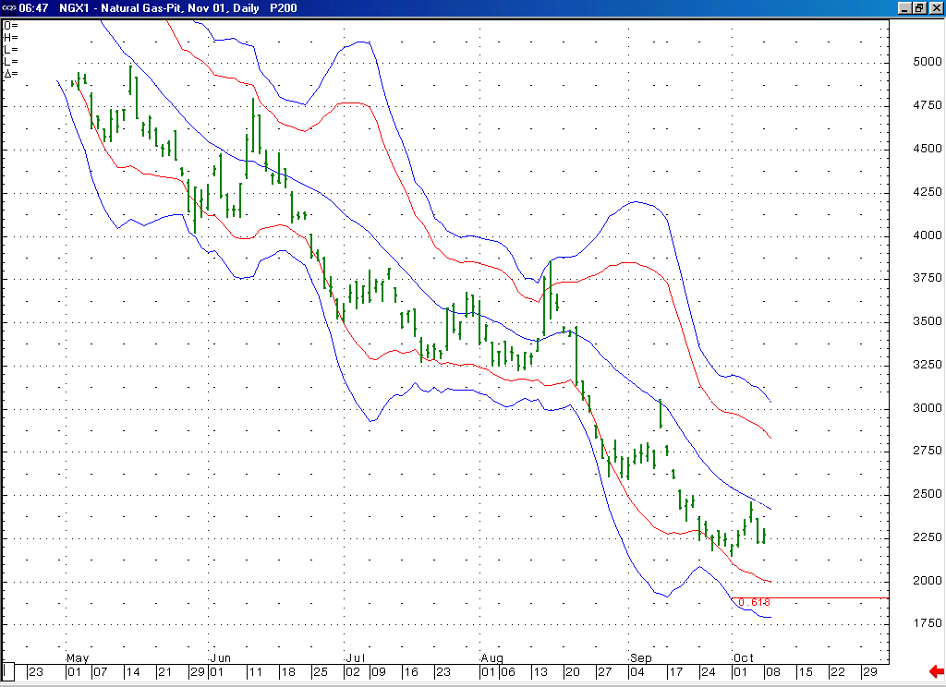
With the market having again turned down from its 20-day average, we should now see it shift its focus on moving down toward the area of its lower Bollinger bands in the days ahead.
Notice that this Fibonacci target (which is derived by extending .618 of waves 1 thru 3 off of the minor wave 4 high at 2.47), located at 1.91, is currently situated right in the area of the markets lower Bollinger bands.

Technical Discussion: The very brief duration (only three sessions) of the move up off of the 2.14 low makes it likely that this “technical” bounce occurred as a portion of the minor degree wave 5 that has been unfolding off of the 3.051 high (as opposed to the bounce that would follow its conclusion). If this is the case, then we would view this bounce as most likely having occurred as the wave 4 of this minor degree wave 5. If this is the case, then we should see the market moving down to a new low (below 2.14) at minimum in the days that follow. Given the manner in which this decline has begun, we would expect this leg of weakness to reach down beyond just its minimum target. The markets intermediated targets for this decline off of the 2.47 high area located in the 2.03 and 1.91 areas.

The information herein is believed to be reliable, however Capstone Trading Advisors Inc. does not warrant its completeness or accuracy. The opinions and estimates contained constitute our judgment and are subject to change without notice. Past performance is not indicative of future results. The information contained herein is not intended as an offer or solicitation for the purchase or sale of any financial instrument or commodities. Chart provided with permission from CQG Inc.

