Capstone Trading Advisors Inc. 830-249-7007

Nat Gas Summary for 10/8/01: With the resistance in the 2.48 to 2.50 area still intact, the market succumbed to its near term overbought condition (as well as it continuing bearish fundamentals) in moving lower on Friday. While the market moving lower in this timeframe was not altogether surprising, we were somewhat surprised to see the size and speed of the drop that occurred on Friday. This occurrence coupled with the market getting below the 2.265 area Friday, should now have the market in a position to continue down to new lows (below 2.14) in the days that follow.

Support: 2.21 2.14 2.03 1.91 Resistance: 2.32 2.375 2.47 2.50-2.53 2.59

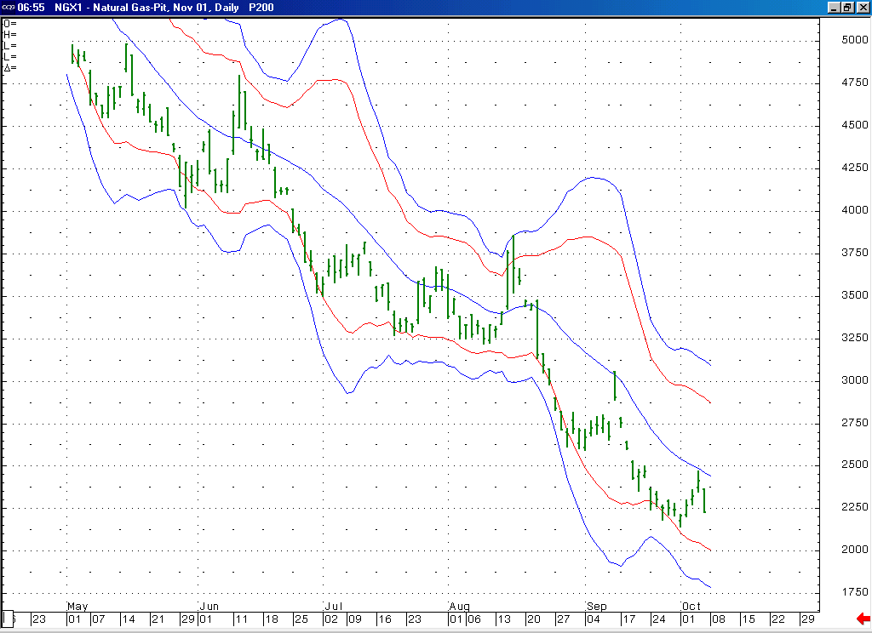
Notice that on this most recent bounce the market was again held in check and turned down from the area of its 20-day average. This should again lead to the market moving down toward its lower Bollinger bands in the days ahead.

Technical Discussion: The very brief duration (only three sessions) of the move up off of the 2.14 low makes it likely that this “technical” bounce occurred as a portion of the minor degree wave 5 that has been unfolding off of the 3.051 high (as opposed to the bounce that would follow its conclusion). If this is the case, then we would view this bounce as most likely having occurred as the wave 4 of this minor degree wave 5. If this is the case, then we should see the market moving down to a new low (below 2.14) at minimum in the days that follow. If the market does get below the 2.14 low in the coming days, then we would expect it at that point to have subsequent targets in the 2.03 and 1.91 areas.

The information herein is believed to be reliable, however Capstone Trading Advisors Inc. does not warrant its completeness or accuracy. The opinions and estimates contained constitute our judgment and are subject to change without notice. Past performance is not indicative of future results. The information contained herein is not intended as an offer or solicitation for the purchase or sale of any financial instrument or commodities. Chart provided with permission from CQG Inc.

