Capstone Trading Advisors Inc. 830-249-7007

Nat Gas Summary for 10/5/01: The anticipated “technical” bounce in the market continued yesterday, carrying up very near our first upside target in the 2.48 to 2.50 area. As the market approaches the 2.50’s, we expect it to begin to encounter some rather significant near term resistance. We continue view the 2.59 area as likely representing the maximum upside target for the market in the coming days. We continue to view the current rally as being a near term selling opportunity. This initial move up toward 2.50 has occurred a little quicker than we had initially envisioned. While we still do not expect this to allow the market to push right through the 2.59 area on this attempt, it may set it up to get above this area in the next week or two after a brief consolidation of the recent gains.

Support: 2.345 2.265 2.21 2.14 2.03 Resistance: 2.485 2.50-2.53 2.59 2.705

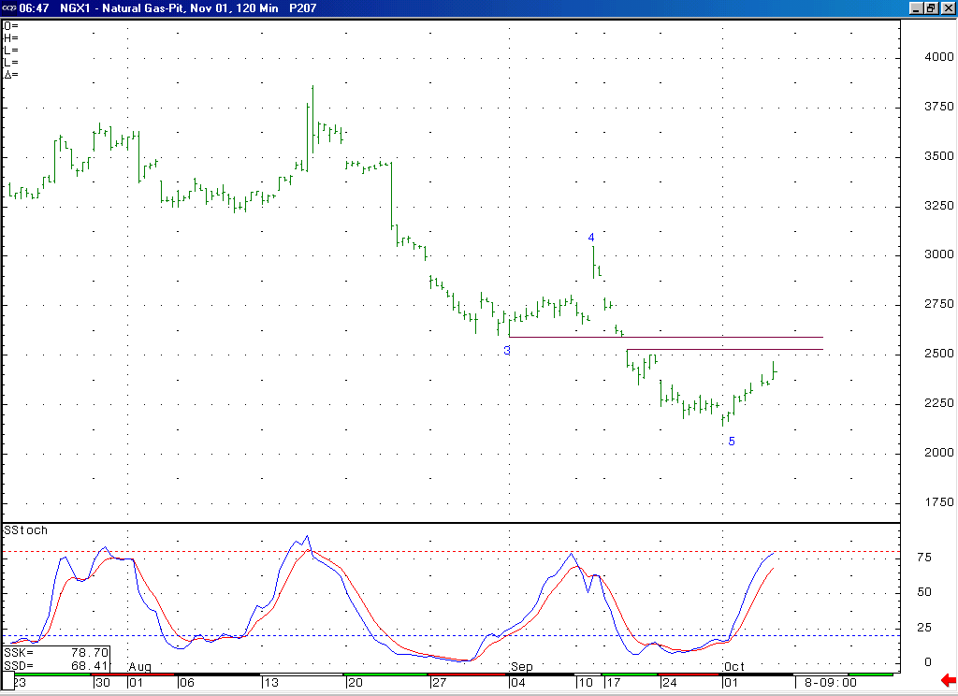
Notice that the market is now moving into a near term overbought position, as witnessed by this 14-bar stochastic.
As the market now approaches the 2.50’s, we expect it to begin to run into some good near term resistance in this area (especially in the 2.59 area, which is the lower end of the lengthy consolidation which occurred in the late August to early September timeframe).

Technical Discussion: We continue to view the recent low at 2.14 as most likely representing the conclusion of a minor degree wave 5 decline. With this being the case, we have been looking for the market to move higher off of this 2.14 low in the near term. At minimum, we are expecting to see the market move higher in another corrective rise (wave 4 of 5). The push up off of the 2.14 low so far does not appear to us at this point to have unfolded in a corrective shape. However, these past several sessions may only have been the initial portion of such a corrective rise (the wave A of the wave 4 for instance). Given that the market should be running into good near term resistance in the 2.50’s (especially in the 2.59 area), and that it is now moving into a near term overbought condition, we would expect the current push higher to soon conclude. While the continuing bearish fundamentals overhanging the market would strongly argue against it, we believe that we should none the less continue to be aware of the alternative Elliott count that would allow for the recent low at 2.14 to be of more significance (end of larger degree wave 5), which would allow for the market to make a more sustained and substantial push up out of this area.

The information herein is believed to be reliable, however Capstone Trading Advisors Inc. does not warrant its completeness or accuracy. The opinions and estimates contained constitute our judgment and are subject to change without notice. Past performance is not indicative of future results. The information contained herein is not intended as an offer or solicitation for the purchase or sale of any financial instrument or commodities. Chart provided with permission from CQG Inc.

