Capstone Trading Advisors Inc. 830-249-7007

Nat Gas Summary for 10/29/01: The fact that the market got above the important short-term resistance in the 3.01 to 3.025 area on Friday opened the door to the prospect of one more marginal new high in the near term. If the market does in fact now move above the 3.10 high, then we would still be surprised to see it getting above what we believe should be good short-term resistance in the 3.20 to 3.22 area. We continue to believe that this entire extremely choppy rally should be very late in its development at this time. If this rally can soon conclude, as we believe should be the case, then the market should have a substantial decline ahead of it (40 to 50 cents and at least a couple of weeks, at minimum).

Support: 2.97 2.915 2.86 2.81 2.69 Resistance: 3.075 3.10 3.20-3.22 3.27

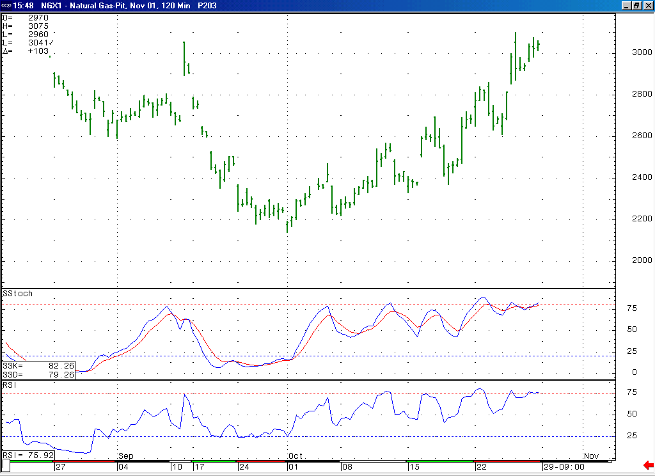
Not only is the market in a near term overbought position here, but if it turns down soon it will also create a bearish momentum divergence here in this Stochastic and RSI on this 120-minute chart.

Technical Discussion: While we still see the primary characteristic of the recent action in the market being the extremely choppy nature of the entire rise off of the early October low (which would still argue that this rise has been occurring in a corrective position), the fact that the market did recently make one more new high did open the door to a bullish interpretation of the recent events (this being the case because the move higher now has 9 waves as opposed to 7). Namely this bullish possibility would state that this rise is occurring in a wave 1 or wave A position in the form of a leading diagonal triangle. While such a formation is rare, it would be even more so in this case given the lack of a converging nature to this move. Even if we were to now favor such a bullish interpretation, we would have to say that this move is now most likely very late in its development, and due for a sizeable and somewhat lengthy decline in order to consolidation these gains. So, the next significant move lower should help us to determine which of these two scenarios is occurring.

The information herein is believed to be reliable, however Capstone Trading Advisors Inc. does not warrant its completeness or accuracy. The opinions and estimates contained constitute our judgment and are subject to change without notice. Past performance is not indicative of future results. The information contained herein is not intended as an offer or solicitation for the purchase or sale of any financial instrument or commodities. Chart provided with permission from CQG Inc.

