Capstone Trading Advisors Inc. 830-249-7007

Nat Gas Summary for 10/26/01: The market did in fact undergo somewhat of a downward reversal early yesterday as we had discussed. If we are going to believe that yesterday’s high is the conclusion of the extremely choppy rise that the market has been unfolding for the past several weeks, then we will need to see it getting materially below the important short-term support in the 2.86 area in an accelerated manner. To the extent that the market is not able to accomplish this relatively soon, it will open the door to the possibility of it pressing back up to challenge its previous high. Also, if the market is going to remain in a near term bearish position, then we believe the important short-term resistance in the 3.01 to 3.025 area should contain it.

Support: 2.86 2.81 2.69 2.61-2.57 Resistance: 2.98 3.01-3.025 3.10 3.20-3.22

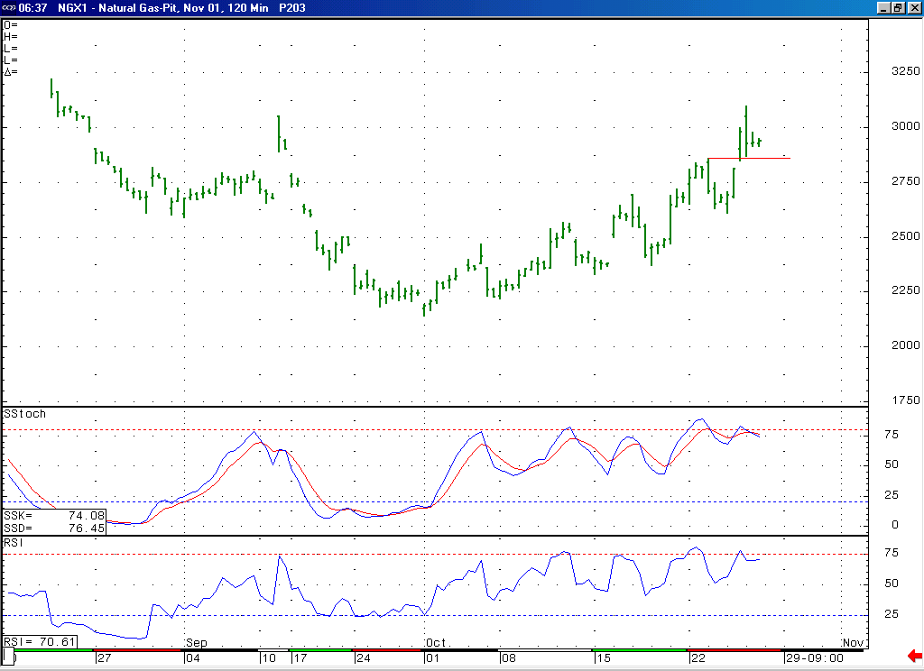
If we are now going to believe that the market has a significant high in place at yesterday mornings high at 3.10, then we will need to see the market soon getting below this important short-term support at 2.86 (right were the market held yesterday).
Notice that if the market can continue lower at this time, as we believe is likely, then it will create a bearish momentum divergence here in both this Stochastic and RSI on this 120-minute chart.

Technical Discussion: While we still see the primary characteristic of what is going on in the market being the extremely choppy nature of the entire rise off of the 3.14 low (which would still argue for the idea that this rise has been most likely occurring in a corrective position), the fact that the market did recently make one more new high did open the door to a bullish interpretation of the recent events (this being the case because the move higher now has 9 waves as opposed to 7). Namely this bullish possibility would state that this rise is occurring in a wave 1 position in the form of a leading diagonal triangle. While such a formation is rare, it would be even more so in this case given the lack of a converging nature in this move. Even if we were to now favor such a bullish interpretation, we would have to say that this move is now most likely late in its development, if not already completed at yesterday mornings high at 3.10, and due for a sizeable and somewhat lengthy decline in order to consolidation these gains. So, the next significant move lower, which we believe may now be underway from the 3.10 high, should help us to determine which of these two scenarios is occurring.

The information herein is believed to be reliable, however Capstone Trading Advisors Inc. does not warrant its completeness or accuracy. The opinions and estimates contained constitute our judgment and are subject to change without notice. Past performance is not indicative of future results. The information contained herein is not intended as an offer or solicitation for the purchase or sale of any financial instrument or commodities. Chart provided with permission from CQG Inc.

