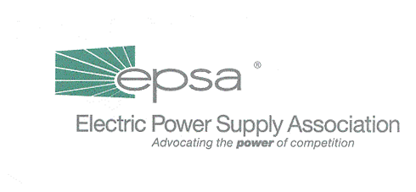

The Washington Summary

The week that just about wasn’t. With Capitol Hill all but shuttered, most staff have been enjoying unseasonably warm weather and an unexpected vacation, albeit one with major tragedies. The Senate and House continue to meet, but the bulk of congressional business is moving slowly or not at all. Although several of the congressional office buildings have reopened, we seem a long way from business as usual.

The House – H.R. 3090, the "Economic Stimulus and Recovery Act of 2001,” passed this week by a razor-thin margin after sharply partisan debate. As the House bill will differ fundamentally in size and scope from any Senate product, count on the real legislative drafting to begin in a the House-Senate conference.

We did hear that Energy and Commerce Committee staff traveled to FERC this week to talk about the Commission’s RTO efforts. There’s no telling how this will affect a new Barton electricity draft. EPSA’s letter to Energy and Air Quality Subcommittee Chairman Joe Barton (R-TX) on his RTO provision went to the Hill (electronically, of course) this week. We expect to meet with the Chairman next week to discuss this critical issue.

The Senate – Little happened this week. Energy and Natural Resources Committee Republicans met midweek to discuss an energy package that would be readied for attachment on the Senate floor to add to any and every available legislative vehicle. The draft will certainly include ANWR and exclude most, if not all, electricity provisions. On Tuesday, Senate Energy and Natural Resources Committee Ranking Member Frank Murkowski (R-AK) confirmed what most insiders expected – that he will be run for Alaska Governor next year.

Both Senate Republicans and Senate Democrats expressed their support for economic stimulus packages considerably less generous than the one that passed the House. Senate Majority Leader Tom Daschle (D-SD) has said that he intends to present the President with a stimulus package by Thanksgiving.

The Senate Environment and Public Works Committee postponed their entire agenda for one week, and the schedule could slip even further. If the Dirksen Senate Office Building doesn’t reopen soon, they’ll have to find a new site for their activities.

The Bush Administration – EPSA was able to welcome back briefly an old friend at Wednesday’s Legislative Affairs Committee Meeting. Jimmy Glotfelty, formerly of Calpine, is now the Department of Energy’s point person on electricity. Mr. Glotfelty detailed the administration’s legislative objectives on electricity. While there were no surprises here—the issues tracked information previously released—he confirmed that the President wants an energy bill and has made it clear to congressional Republicans that progressive electricity provisions are “as important as ANWR” in the package. Mr. Glotfelty also wanted to make EPSA members aware of two administrative initiatives: (1) the President’s Council on Environmental Quality (http://www.whitehouse.gov/ceq) has initiated an effort to streamline federal siting projects and referee disputes between likely developers and federal agencies and (2) the administration is putting together a final report on the National Transmission Grid Study (www.ntgs.doe.gov), Jimmy urged members to submit any final comments ASAP.

KEY DATES

Oct. 26 – Environmental Affairs Committee Conference Call at 2:00 p.m. EDT.
Nov. 1 – EPSA-PAC event for Congressman George Radanovich (R-CA). For details contact Jodi Empol (202-628-8200 or jempol@epsa.org).
Nov. 1 – Accounting Working Group Conference Call at 2:00 p.m. EST.

To access all Legislative Affairs Committee, Tax Policy Working Group, Accounting Working Group and Environmental Issues Committee Conference Calls, dial 1-800-937-6563 and ask for the EPSA call moderated by Gene Peters.

