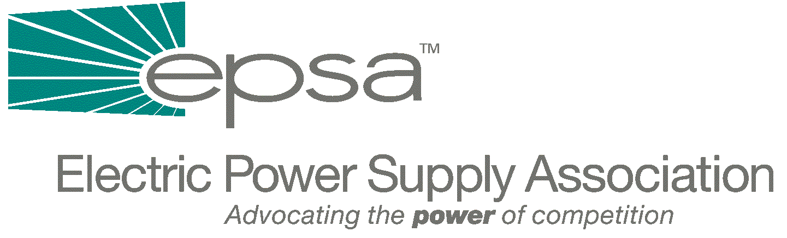

1401 New York Avenue, NW
Suite11th Floor
Washington, DC 20005
202/628-8200
202/628-8260 fax
epsa@mindspring.com
www.epsa.org
Memorandum
TO: | Legislative Affairs Committee
FROM: | Scott A. Weiner, Legislative Affairs Committee Chair  Eugene F. Peters, Vice President of Legislative Affairs
DATE: | October 24, 2001
RE: | CANCELLED: Thursday, October 25th Legislative Affairs Committee Biweekly Conference Call/Meeting

Due to EPSA’s Fall Membership Meeting being held this week, the biweekly Legislative Affairs Committee conference call/meeting regularly scheduled for Thursday, October 25th has been cancelled. The next biweekly conference call/meeting will be held on Thursday, November 8th at 3:00 p.m., EST.

