Capstone Trading Advisors Inc. 830-249-7007

Nat Gas Summary for 10/25/01: The market continued in its extremely choppy mode when it followed the recent sharp push down by exploding substantially higher yesterday afternoon after the release of a surprisingly small AGA injection. Now that the market has gotten above the recent high, its next significant resistance is located in the 3.05 area. If the market were to get substantially above this area, then the next significant resistance above here is located in the lower 3.20’s. We would be quite surprised to see the market above the higher of these two resistance areas in the coming days. In the near term is will be very important to see if the market can hang onto yesterday’s reactionary gains. We would be cautious of a potential reversal occurring in the first half of this morning session (potentially similar to what happened after the release of a surprisingly bullish AGA number on August 15th, when the market opened higher the next morning following the big gains the previous afternoon, and at that point put in the high of a nearly month long consolidation in the market).

Support: 2.86 2.76 2.69 2.61-2.57 Resistance: 3.00 3.05 3.20-3.22 3.27

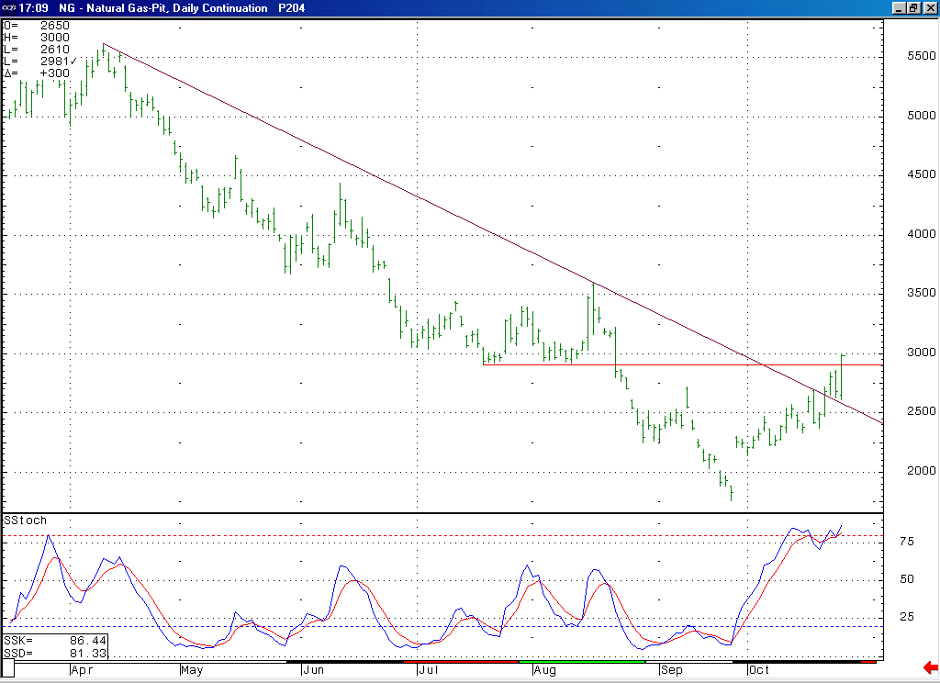
Even if one were to favor the emerging wave 1 leading diagonal bullish scenario, the fact that the market is now in a quite overbought position on this daily chart would cause an expectation for this move to soon conclude and give way to a wave 2 pullback.
While the perpetual chart does not paint a clearly bullish picture for the market either, it does have some characteristics that do look more bullish than the Nov contract (breaking above this longstanding trend line, retesting it and then moving on to new highs; and getting above the very good structural resistance in the 2.92 area).

Technical Discussion: While we still see the primary characteristic of what is going on in the market being the extremely choppy nature of the entire rise off of the 3.14 low (which would still argue for the idea that this rise has been most likely occurring in a corrective position), the fact that the market did make a new high yesterday did open the door to a bullish interpretation of the recent events (this being the case because the move higher now has 9 waves as opposed to 7). Namely this bullish possibility would be if this rise were occurring in a wave 1 position in the form of a leading diagonal triangle. While such a formation is rare, it would be even more so in this case given the lack of a converging nature in this move. Even if we were to now favor such a bullish interpretation, we would have to say that this move is now most likely late in its development, and due for a sizeable and somewhat lengthy consolidation of this move higher. So, the next significant move lower, which we believe should occur soon, should help us to determine which of these two scenarios is occurring.

The information herein is believed to be reliable, however Capstone Trading Advisors Inc. does not warrant its completeness or accuracy. The opinions and estimates contained constitute our judgment and are subject to change without notice. Past performance is not indicative of future results. The information contained herein is not intended as an offer or solicitation for the purchase or sale of any financial instrument or commodities. Chart provided with permission from CQG Inc.

