Capstone Trading Advisors Inc. 830-249-7007

Nat Gas Summary for 10/24/01: If the market was going to support the idea that the recent very choppy rally was going to give way to another substantial push lower at this time, then we had ideally wanted to see the market turn lower in a forceful manner during the first half of yesterday’s sessions. And in fact this is just the type of action that was seen from the market. Getting below the short-term support in the 2.69 to 2.65 area yesterday afternoon also furthered the markets near term bearish potential. In order to continue to support this short-term bearish potential, we will now want to see any upward movements occurring in the market remaining well contained. We expect the market to move down toward the low 2.40’s to high 2.30’s at minimum in the near term, and we still believe that the market has a good chance of moving below its previous low (2.535 in the December contract) in the weeks ahead.

Support: 2.63 2.57 2.50 2.47 2.415 Resistance: 2.72 2.75 2.77 2.86 2.89

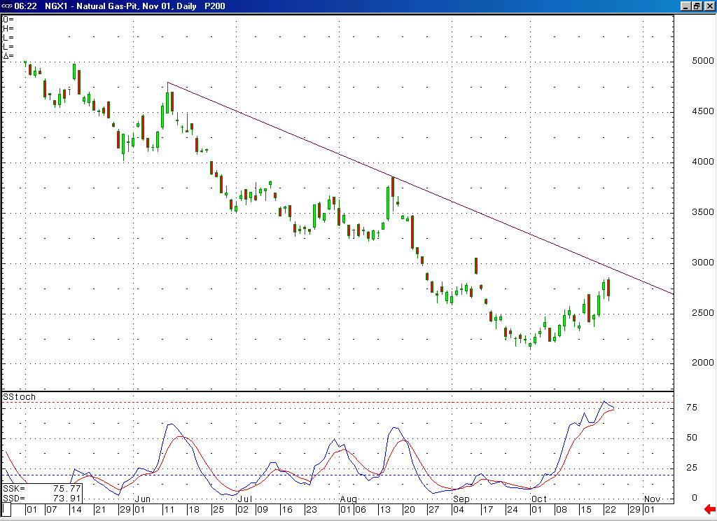
Notice how this 14-day stochastic is now in the process of rolling over from the most overbought position that it has seen in many months.
Notice here on this candlestick chart the engulfing pattern that occurred yesterday (which is a reversal pattern). Unlike the similar pattern that occurred last Wednesday, this reversal occurred after the market had seven waves up off of the recent low (necessary for the completion of a double three correction).

Technical Discussion: We have recently been viewing the extremely choppy move up off of the early October low at 2.14 as a double three correction that was very late in its development. If this was the case, then we had ideally wanted to see the market turning down in this timeframe in a clearly impulsive manner to indicate that this double three correction had come to a conclusion. With the market turning down in just such a manner yesterday morning, and moving down to take out the first significant short-term support in the 2.69 to 2.65 area in short order, it now appears probable that this double three has in fact concluded at yesterday’s high of 2.86. This scenario would call for the market to now be in the process of moving down to a new low (below 2.535 in the December contract) in an impulsive manner in the weeks that follow. The next significant short-term support that the market should encounter along the way should be located in the 2.415 to 2.37 area.

The information herein is believed to be reliable, however Capstone Trading Advisors Inc. does not warrant its completeness or accuracy. The opinions and estimates contained constitute our judgment and are subject to change without notice. Past performance is not indicative of future results. The information contained herein is not intended as an offer or solicitation for the purchase or sale of any financial instrument or commodities. Chart provided with permission from CQG Inc.

