Capstone Trading Advisors Inc. 830-249-7007

Tuesday October 23, 2001

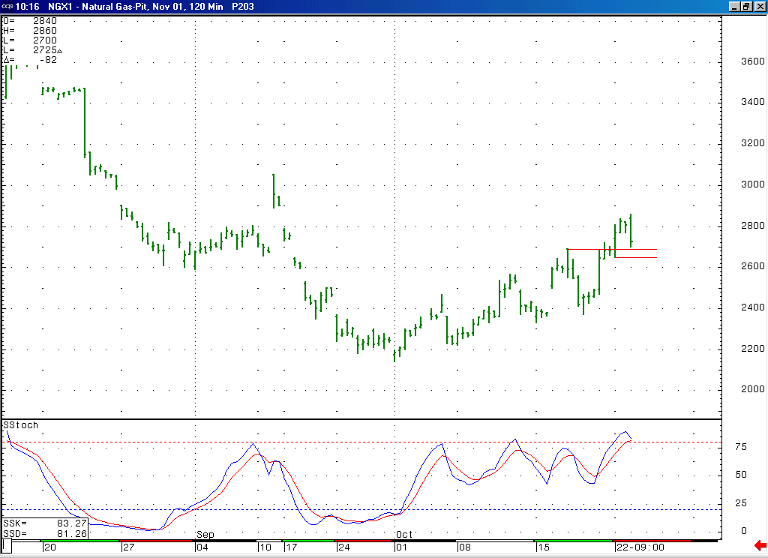
If the market was going to support the idea that its double three corrective rise off of the 2.14 low was coming to a conclusion at this time, then we had wanted to see it turn down forcefully in the first half of today’s session. What we have witnessed so far today is in keeping with this thought. But in order to further confirm the idea that this corrective rise has come to its conclusion, we really need to see the market getting below the important short-term support in the 2.69 to 2.65 area relatively soon.
Notice how this 14-bar stochastic on this 120-minute chart is now trying to turn down from a quite overbought position. This is supportive of the case for this choppy rise coming to a conclusion in this timeframe.

The information herein is believed to be reliable, however Capstone Trading Advisors Inc. does not warrant its completeness or accuracy. The opinions and estimates contained constitute our judgment and are subject to change without notice. Past performance is not indicative of future results. The information contained herein is not intended as an offer or solicitation for the purchase or sale of any financial instrument or commodities. Chart provided with permission from CQG Inc.

