Capstone Trading Advisors Inc. 830-249-7007

Nat Gas Summary for 10/23/01: Yesterday the market moved somewhat above the upper end (the 2.79 to 2.805 area) of our short-term resistance zone. While this occurrence does not change our general belief that the very choppy nature of the current rally should indicate that it is most likely to give way to another substantial push lower once it has concluded, it does open the door to the possibility of the market testing higher resistance levels prior to this rally concluding. If the market does not turn down forcefully very soon (ideally within the first half of today’s session) from marginally above this 2.805 area, then the next significant resistance areas that are open to be tested lie in the 2.91 area (basis the perpetual), and the 3.05 area (which is the reactionary high made in mid September).

Support: 2.69-2.65 2.57-2.545 2.47 2.37 Resistance: 2.84 2.89 2.91 2.99 3.05

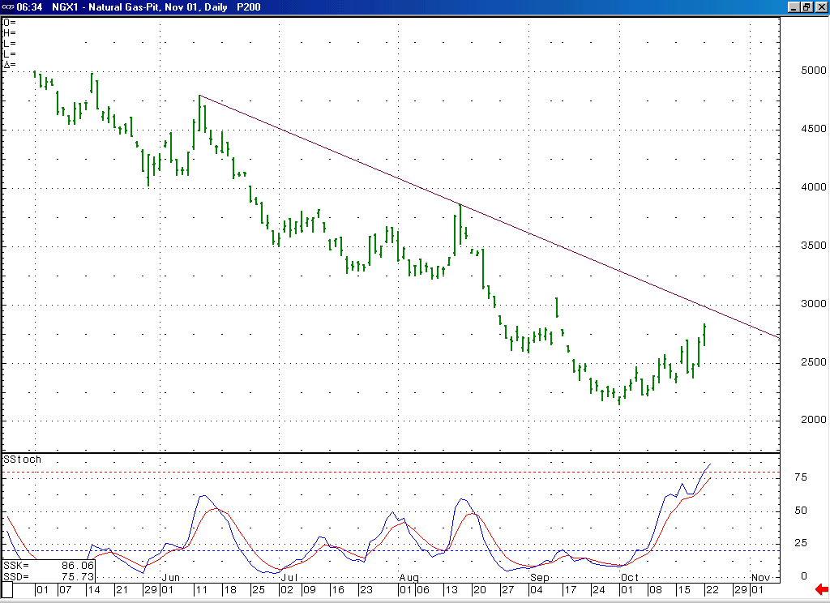
This longstanding daily trend line on the November chart is located at 2.96 today.
As you can see here with this 14-day stochastic, the market is now in a more overbought condition than has been witnessed in many months. This overbought state should carry significance at this time given the very choppy nature of the recent rise off of the 2.14 low.

Technical Discussion: At this time we continue to believe that the extremely choppy nature of the entire rise off of the early October low at 2.14 should indicate that it is occurring as a correction (most likely a double three). If this is the case, then we had ideally expected to see this double three conclude relatively soon and near the 2.76 to 2.805 short-term resistance area. The fact that the market carried somewhat above this area yesterday does not at this point change our opinion of this advance occurring as a double three. But if the market is unable to reverse from marginally above this 2.805 area very soon, then this will open the door to the possibility of the market finishing this double three in an overshoot (the market carrying up rather quickly to an extreme prior to reversing very sharply) of its ideal target area. If this does occur, then the next significant resistance points we would focus on are located in the 2.91 and 3.05 areas. Given the extreme two-sided volatility that has been witnessed in the market of late, we would expect the market to signal the conclusion of its current advance with an extremely sharp and sizeable initial decline.

The information herein is believed to be reliable, however Capstone Trading Advisors Inc. does not warrant its completeness or accuracy. The opinions and estimates contained constitute our judgment and are subject to change without notice. Past performance is not indicative of future results. The information contained herein is not intended as an offer or solicitation for the purchase or sale of any financial instrument or commodities. Chart provided with permission from CQG Inc.

