Capstone Trading Advisors Inc. 830-249-7007

Nat Gas Summary for 10/22/01: The market got above the important short-term resistance at the 2.55 level early on Friday. This occurrence opened the door up for the market to make one more marginal new high, above 2.69, prior to concluding its current very choppy rise. And in fact the market was able to carry all the way up above this 2.69 high on Friday as well (this occurred quite a bit quicker than we had expected). We continue to believe that the extremely choppy nature of the entire advance off of the early October low at 2.14 should indicate that once it has concluded (which we believe should occur soon), it should give way to another significant push lower in the market. We would expect the market to now encounter good short-term resistance throughout the 2.70’s.

Support: 2.64 2.57 2.51 2.47 2.37 Resistance: 2.72 2.73 2.76 2.79-2.805

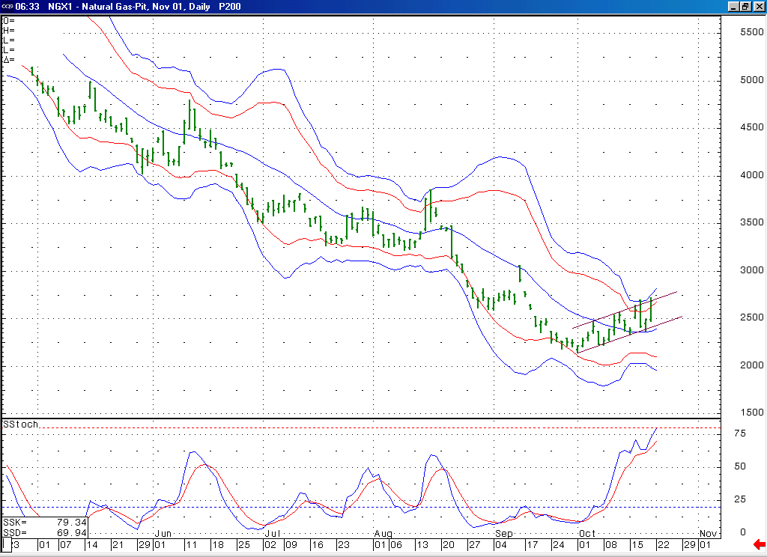
The market is now in a more overbought condition than has been witnessed at any point in quite a few months.
The market failed to get below its 20-day average here, and with this moved back up to its upper Bollinger bands. The choppy / channeling nature of this entire rise still leads us to believe that it is corrective in nature, and therefore will give way to another significant push lower once it has concluded.

Technical Discussion: We have been viewing the advance off of the early October low at 2.14 as most likely occurring as a correction given its very choppy development so far. As to what type of correction, we had been leaning toward a double three. In looking at the November contract (as opposed to the perpetual) it appeared that the market needed one more marginal new high (above 2.69) in order to complete this double three formation. Getting above the 2.55 level on Friday made it more likely that this marginal new high would in fact occur. Now that the market has made this marginal new high above 2.69, we believe that this double three correction should be very late in its development. We would ideally like to see the market turn down in the next couple of sessions in an impulsive manner from the resistance in the mid 2.70’s in order to indicate that this double three correction has concluded. Getting below the lower end of its recent channel, and its last swing low at 2.37, will now be the confirmation we are looking for to indicate that the significant decline that we are anticipating following this correction is underway.

The information herein is believed to be reliable, however Capstone Trading Advisors Inc. does not warrant its completeness or accuracy. The opinions and estimates contained constitute our judgment and are subject to change without notice. Past performance is not indicative of future results. The information contained herein is not intended as an offer or solicitation for the purchase or sale of any financial instrument or commodities. Chart provided with permission from CQG Inc.

