Capstone Trading Advisors Inc. 830-249-7007

Nat Gas Summary for 10/19/01: The very choppy nature of the entire advance off of the 2.14 low, along with the steepness of all three drops within this choppy advance, we believe should suggest that this advance will give way to another substantial push lower once it has concluded. If the market is going to make the case that this substantial decline is now underway, then we will need to see it soon turning down from the lower 2.50’s area, and would prefer to not see it getting above the 2.55 level. If the market were to soon get above this 2.55 area, then this would open the door to the possibility that the market will continue this choppy rise off of the 2.14 low a little while longer prior to this anticipated significant decline occurring. Once this anticipated significant decline is in fact underway, it should target a move below this previous low at 2.14 at minimum.

Support: 2.425 2.37 2.33 2.22 2.14 Resistance: 2.505 2.535 2.55 2.64 2.69

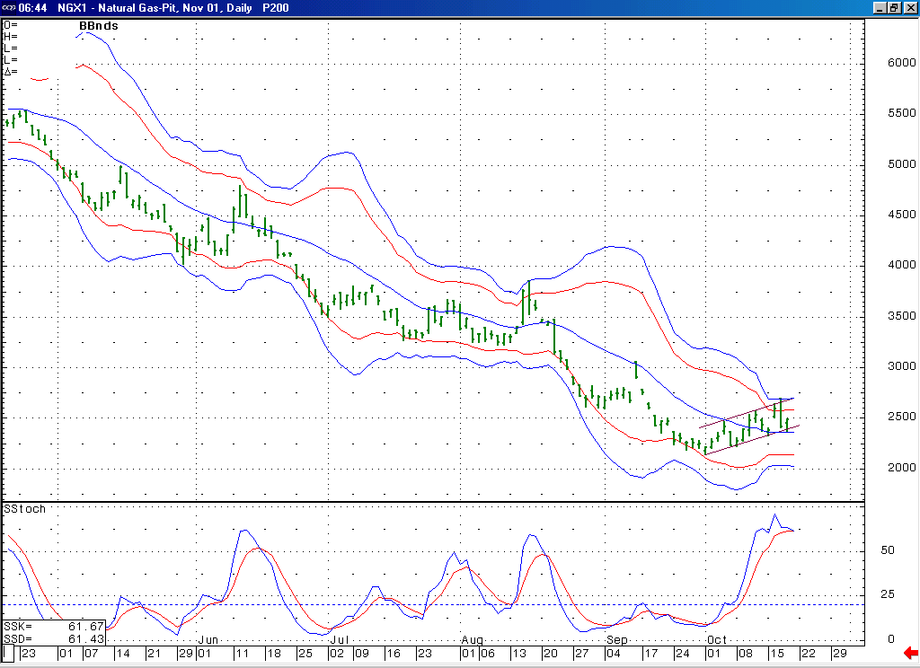
Notice that this stochastic is now beginning to turn down from a similar area to where it turned down the last two times.
After stalling right at its upper Bollinger bands here, the market has now moved down to the 20-day average. If it can soon push below here this should allow for it to follow through towards its lower Bollinger bands in the days that follow.

Technical Discussion: The very choppy nature of the entire advance off of the 2.14 low appears to us to have a corrective signature. If this is the case, then we would still view this advance as most likely occurring as the second wave 4 in the series of two waves 4 and 5 that we have been discussing. And we would have to view this corrective rise as most likely occurring in the form of a double three. The very hard break off of the 2.69 high that has recently occurred brings to the forefront the possibility that this corrective advance may now be completed at this high. In looking at the November chart, this pattern is less than ideal from an Elliott standpoint, but this case can be made much better when looking at the perpetual chart. The November chart looks like it actually needs another push up above the 2.69 high in order to complete this double three formation. The perpetual chart appears that this double three should already be completed at the recent high of 2.69. If the market were to soon get above the 2.55 area this would begin to favor the case made by the November chart, if it were to soon get below the 2.33 area this would favor the case made by the perpetual.

The information herein is believed to be reliable, however Capstone Trading Advisors Inc. does not warrant its completeness or accuracy. The opinions and estimates contained constitute our judgment and are subject to change without notice. Past performance is not indicative of future results. The information contained herein is not intended as an offer or solicitation for the purchase or sale of any financial instrument or commodities. Chart provided with permission from CQG Inc.

