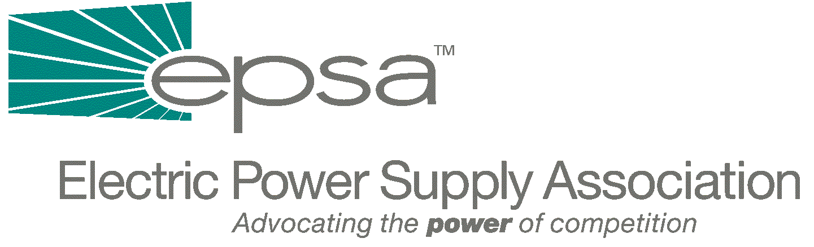
1401 New York Avenue, NW
11th Floor
Washington, DC 20005
202/628-8200
202/628-8260 fax
www.epsa.org
Memorandum

TO: | EPSA Legislative Affairs Committee
FROM: | Scott A. Weiner, Legislative Affairs Committee Chair  Eugene F. Peters, Vice President of Legislative Affairs
DATE: | October 18, 2001
RE: | REMINDER: Legislative Affairs Committee Conference Call/Meeting Today Thursday, October 18, at 3:00 p.m., EDT.

We will hold a Legislative Affairs Committee Conference Call/Meeting today Thursday, October 18th, at 3:00 p.m. EDT. The call/meeting will be held at EPSA (1401 New York Avenue, 11th Floor). To access the call, dial 1-800-937-6563 and ask for the EPSA call moderated by Gene Peters.
This call will allow us to continue discussions that began on last week’s call. We will discuss EPSA’s response to possible electricity legislation and, specifically, the proposals likely to form the electricity provisions of Senate energy legislation. We have asked members to review both the original Jeff Bingaman (D-NM) electricity draft and the administration’s proposed changes. Both documents, and legislative summaries, are available from EPSA.

If you have any questions, please contact Gene Peters (202-628-8200 or gpeters @epsa.org).

