Capstone Trading Advisors Inc. 830-249-7007

Nat Gas Summary for 10/18/01: The very choppy nature of the entire advance off of the 2.14 low, along with the steepness of the first two drops within this choppy advance (off of the 2.47 and 2.57 highs), we believed should suggest that this advance would give way to another substantial push lower once it has concluded. And in fact after the report of a slightly higher than expected AGA number yesterday, the market did turn down quite briskly. If the market is now going to maintain its near term bearish momentum from here, and make the case that the recent short covering rally has concluded at the recent high at 2.69, then we will need to see it getting below the key short term support at 2.33 rather quickly. We still believe that this rise off of the 2.14 low, due to its very choppy nature, should eventually give way to a move back below this 2.14 low.

Support: 2.395 2.35-2.33 2.22 2.14 Resistance: 2.515 2.55 2.58 2.64 2.69

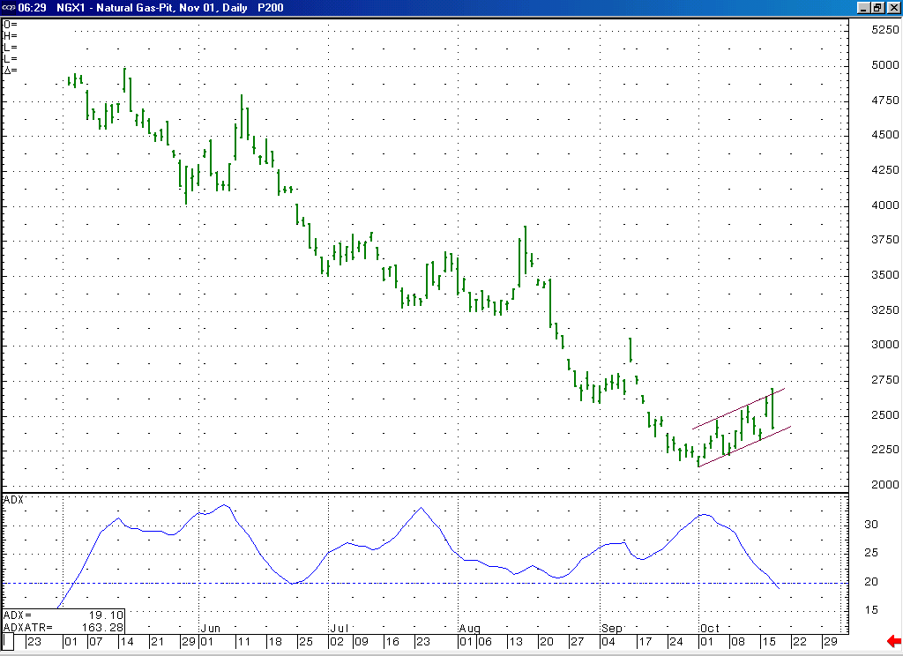
Notice how this ADX has been sharply declining since the market put in the 2.14 low. This would support our argument that this rally is occurring as a countertrend short covering rally.
We had felt that the very choppy nature of this channeling move higher would suggest that it should give way to another substantial push lower at its conclusion. If the market can now push below the lower end of this channel, as well as the key short-term support at 2.33, then this would argue that this substantial push lower is now underway.

Technical Discussion: The very choppy nature of the entire advance off of the 2.14 low appears to us to have a corrective signature. If this is the case, then we would still view this advance as most likely occurring as the second wave 4 in the series of two waves 4 and 5 that we have been discussing. And we would have to view this corrective rise as most likely occurring in the form of a double three. The very hard break that was witnessed yesterday afternoon would bring to the forefront the possibility that this corrective advance may now be completed at yesterday’s 2.69 high. In looking at the November chart, this pattern is less than ideal from an Elliott standpoint, but this case can be made much better when looking at the perpetual chart. In any case, if the market were to now be able to move below the key short-term support at 2.33 in an impulsive manner, then this would greatly bolster the argument for this short covering rally having concluded at 2.69.

The information herein is believed to be reliable, however Capstone Trading Advisors Inc. does not warrant its completeness or accuracy. The opinions and estimates contained constitute our judgment and are subject to change without notice. Past performance is not indicative of future results. The information contained herein is not intended as an offer or solicitation for the purchase or sale of any financial instrument or commodities. Chart provided with permission from CQG Inc.

