Capstone Trading Advisors Inc. 830-249-7007

Nat Gas Summary for 10/17/01: The very choppy nature of the entire advance off of the 2.14 low, along with the steepness of the last two drops within this choppy advance (off of the 2.47 and 2.57 highs), would suggest that this advance should give way to another substantial push lower once it has concluded. However, with the market getting above its previous high at 2.57, as well as the short-term resistance in the 2.59 to 2.61 area yesterday, we do not at this time see a scenario that calls for the conclusion of this choppy rise to be imminent. Remember at last report the “funds” were still carrying a rather sizeable short position (25,000 contracts net), and given a catalyst (such as appeared yesterday) they will be susceptible to being forced to cover a portion of these positions. The next significant resistance for the market should now occur in the lower to mid 2.70’s. We expect the high volatility that has been witnessed of late to continue in the days ahead.

Support: 2.525 2.485 2.45 2.395 2.33 Resistance: 2.645 2.705 2.72 2.75-2.76

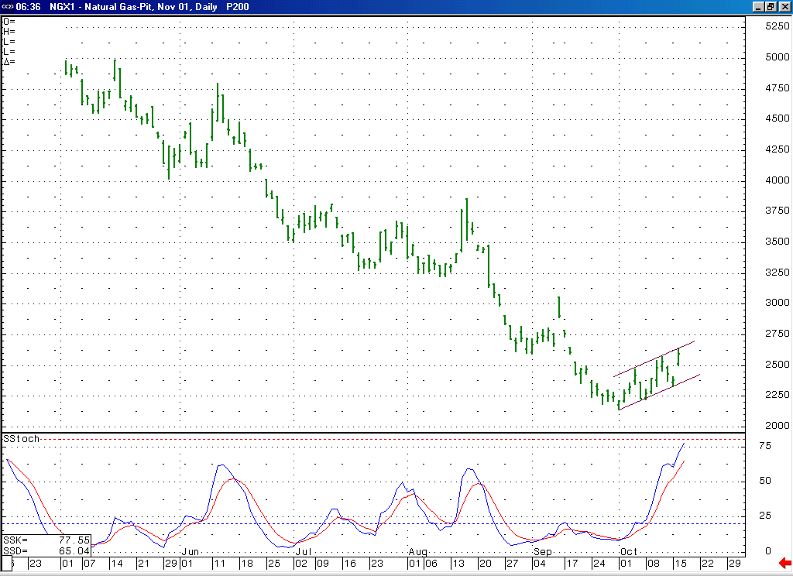
The choppy nature of this advance to this point off of the 2.14 low (you can see here how this move has been channeling higher) would suggest to us that it is of a corrective nature. However, to this point it does not give us a definitive signal that its conclusion is imminent (it appears to most likely be a double three still in progress).
Notice here how this 14-day stochastic is now moving up into an overbought position for the first time in many months.

Technical Discussion: The very choppy nature of the entire advance off of the 2.14 low appears to us to have a corrective signature. If this is the case, then we would still view this advance as most likely occurring as the second wave 4 in the series of two waves 4 and 5 that we have been discussing. At this time however, this rise does not have a definitive pattern that would call for its conclusion to be imminent. This fact would allow for the market to continue chopping its way higher for a little while longer prior to eventually giving way to the anticipated corresponding wave 5 impulsive decline. At the conclusion of this anticipated wave 5 we will then expect the market to begin a more substantial and sustained push back to the upside. While the fact that we view the recent low at 2.14 as also occurring in a minor degree wave 5 position could allow for such a substantial move higher to now be occurring, the shape that this rise off of the 2.14 low has taken on so far (the most impulsive parts of this choppy advance so far have been the two drops within it, off of the 2.47 and 2.57 highs) would argue against this being the case at this time.

The information herein is believed to be reliable, however Capstone Trading Advisors Inc. does not warrant its completeness or accuracy. The opinions and estimates contained constitute our judgment and are subject to change without notice. Past performance is not indicative of future results. The information contained herein is not intended as an offer or solicitation for the purchase or sale of any financial instrument or commodities. Chart provided with permission from CQG Inc.

