Capstone Trading Advisors Inc. 830-249-7007

Tuesday October 16, 2001

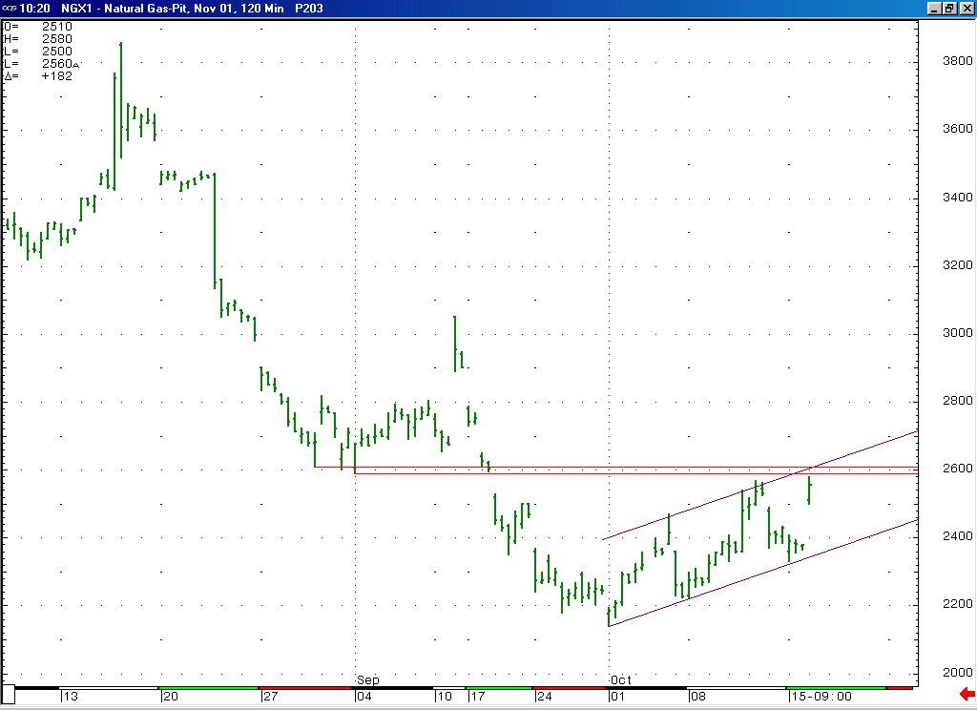
With the sharp / impulsive decline that recently occurred off of the 2.57 high, we did not anticipate that high being exceeded any time soon. With this morning’s action this has now occurred. Exactly where this leaves the market from an Elliott perspective is not terribly clear at this moment. The choppy (notice how it is moving higher within this channel) nature of this entire advance off of the 2.14 low still appears to us to give this move a corrective appearance. And we would still expect the market to still encounter good short-term resistance in the 2.59 to 2.61 area. With this being the case, it would not surprise us to see this advance run out of steam in this area. But it will take a read on the subsequent action to firm up the expectations going forward from the Elliott perspective.

The information herein is believed to be reliable, however Capstone Trading Advisors Inc. does not warrant its completeness or accuracy. The opinions and estimates contained constitute our judgment and are subject to change without notice. Past performance is not indicative of future results. The information contained herein is not intended as an offer or solicitation for the purchase or sale of any financial instrument or commodities. Chart provided with permission from CQG Inc.

