Capstone Trading Advisors Inc. 830-249-7007

Nat Gas Summary for 10/16/01: After being held in check by the very good short-term resistance in the mid to upper 2.50’s late last week, and then turning down convincingly in the days that followed, the market should now be left in a near term bearish position. In the next week or two, we expect the market move down below its early October low at 2.14 in a rather direct manner. Stops on any short positions should now be carried just above the recent high at 2.57 (although it would be best for the markets short term bearish potential to not see it getting materially above the resistance in the 2.49 area at this time).

Support: 2.33 2.305 2.22 2.14 2.03 Resistance: 2.435 2.49 2.525 2.57 2.59-2.61

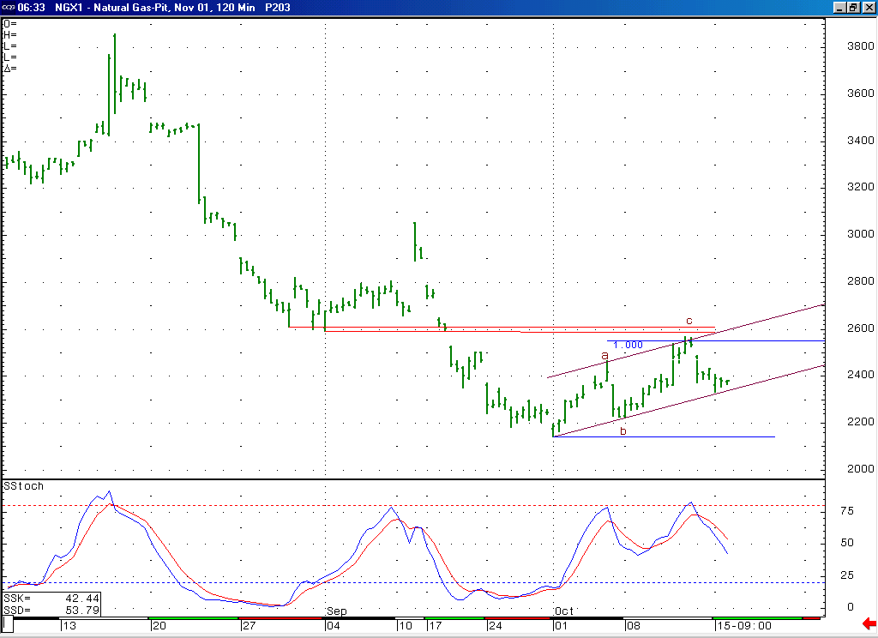
With the market having recently turned down rather sharply from the resistance in the mid to upper 2.50’s, this now gives this entire rise off of the 2.14 low a corrective appearance (as you can see labeled with the a-b-c here). If this rally was in fact corrective in nature, then it should be followed by an impulsive decline that carries the market back below this 2.14 low.

Technical Discussion: The market does appear to have concluded its recent strength in the mid to upper 2.50’s area late last week as we had anticipated, which gives the entire advance off of the early October low at 2.14 a corrective appearance (an a-b-c as you can see labeled above). If this rise did in fact occur as a correction, then we would have to believe that this is most likely the second wave 4 in the series of two waves 4 and 5 that we have been discussing. If this minor degree wave 4 has now concluded, as appears likely, then the market should now unfold the subsequent minor degree wave 5, which would call for it to move down below this 2.14 low at minimum in the days / weeks that follow. If this decline is in fact occurring as a minor degree wave 5, as we believe is the case, then it should be a concluding move lower, and should therefore be followed by a more substantial move back to the upside when it is finished.

The information herein is believed to be reliable, however Capstone Trading Advisors Inc. does not warrant its completeness or accuracy. The opinions and estimates contained constitute our judgment and are subject to change without notice. Past performance is not indicative of future results. The information contained herein is not intended as an offer or solicitation for the purchase or sale of any financial instrument or commodities. Chart provided with permission from CQG Inc.

