Capstone Trading Advisors Inc. 830-249-7007

Nat Gas Summary for 10/15/01: The market was held in check by the very good short-term resistance in the mid to upper 2.50’s late last week, and was able to turn down from this area convincingly as anticipated. This occurrence should now leave the market in a near term bearish position. In the next week or two we expect the market move down below its early October low at 2.14 in a rather direct manner. Stops on any short positions should now be carried just above the recent high at 2.57 (although it would be best for the markets short term bearish potential to not see it getting materially above the resistance in the 2.49 area at this time).

Support: 2.355 2.305 2.22 2.14 2.03 Resistance: 2.445 2.49 2.525 2.57 2.59-2.61

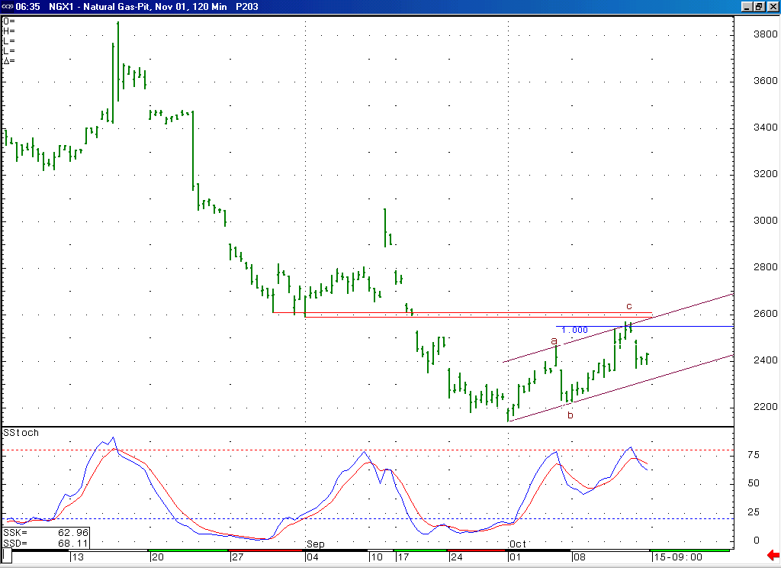
The fact that the market was able to turn down impulsively from the resistance clustered in the 2.55 to 2.61 area gives this entire advance off of the early October low at 2.14 a corrective appearance (most likely occurring in a minor degree wave 4 position.

Technical Discussion: The market does appear to have concluded its recent strength in the mid to upper 2.50’s area late last week as we had anticipated, which gives the entire advance off of the early October low at 2.14 a corrective appearance (an a-b-c as you can see labeled above). If this rise did in fact occurring as a correction, then we would have to believe that this is the second wave 4 in the series of two waves 4 and 5 that we have been discussing. If this minor degree wave 4 has now concluded, as appears likely, then the market should now unfold the subsequent minor degree wave 5, which would call for it to move down below this 2.14 low at minimum in the days / weeks that follow. If this decline is in fact occurring as a minor degree wave 5, as we believe is the case, then it should be a concluding move lower, and should therefore be followed by a more substantial move back higher when it is finished.

The information herein is believed to be reliable, however Capstone Trading Advisors Inc. does not warrant its completeness or accuracy. The opinions and estimates contained constitute our judgment and are subject to change without notice. Past performance is not indicative of future results. The information contained herein is not intended as an offer or solicitation for the purchase or sale of any financial instrument or commodities. Chart provided with permission from CQG Inc.

