Capstone Trading Advisors Inc. 830-249-7007

Nat Gas Summary for 10/12/01: The market moved up yesterday to challenge what we believe should be very good short-term resistance in the mid to upper 2.50’s. We continue to believe that this resistance should turn the market back, and that this should occur quite soon (ideally today, but may take until early Monday). If the market can turn down with conviction from this area in this timeframe, then this should set it up to make a move back down toward its early October low at 2.14 in the days / weeks that follow. If on the other hand the market were to be able to break out materially above this very good short term resistance (the top of which is located in the 2.59 to 2.61 area), then this should cause quite a bit larger bout of short covering that could carry the market a considerable distance higher in the days that follow (remember that the “funds” were still short about 23,000 contracts at last report).

Support: 2.47 2.41 2.355 2.295 2.22 Resistance: 2.57 2.59-2.61 2.705 2.72 2.755

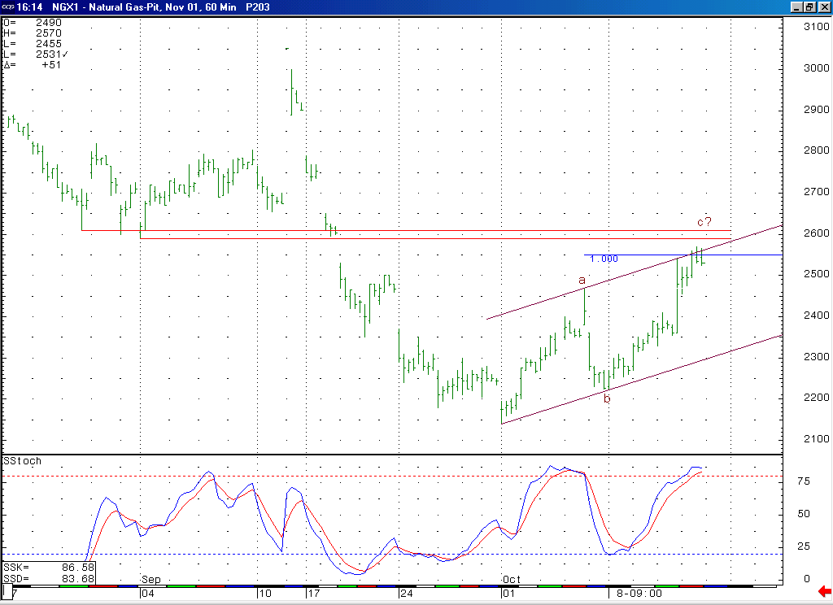
The fact that the market is now in a near term overbought position, as witnessed by this 14-bar stochastic on this weekly chart, would support the idea that the market should be turning down in this timeframe.
At this time we continue to expect the market to be turned back by what we believe should be very good short-term resistance in the mid to upper 2.50’s (the top of which is located in the 2.59 to 2.61 area).

Technical Discussion: If the market were to soon conclude its current leg of strength near its current levels (being held in check by the very good short-term resistance in the mid to upper 2.50’s), as we believe is likely, then this entire advance off of the 2.14 low would have a corrective appearance (an a-b-c as you can see labeled above). If this rise is in fact occurring as a correction, then we would have to believe that this is the second wave 4 in the series of two waves 4 and 5 that we have been discussing. And if this wave 4 were to soon end, then the subsequent wave 5 would call for the market to move down below the 2.14 low at minimum in the days / weeks that follow. In order to get the market into a bullish position technically, we would need to see the market now break out above this very good short term resistance (the top of which is in the 2.59 to 2.61 area), and to do this in a very accelerated manner.

The information herein is believed to be reliable, however Capstone Trading Advisors Inc. does not warrant its completeness or accuracy. The opinions and estimates contained constitute our judgment and are subject to change without notice. Past performance is not indicative of future results. The information contained herein is not intended as an offer or solicitation for the purchase or sale of any financial instrument or commodities. Chart provided with permission from CQG Inc.

