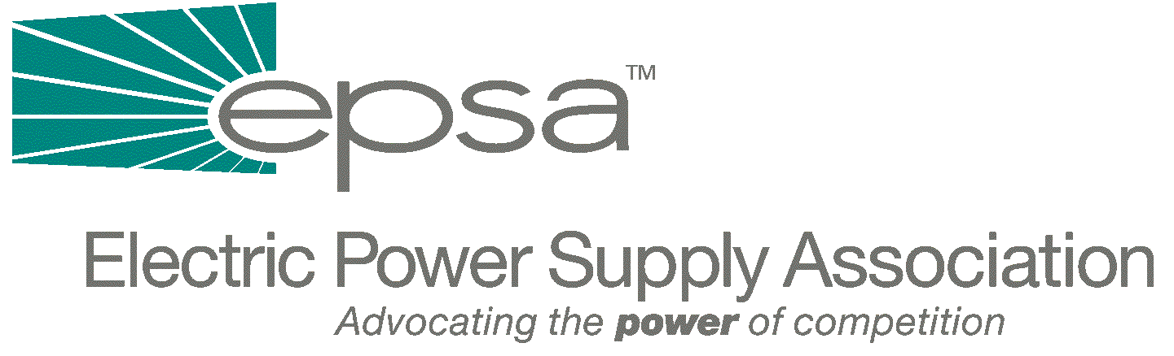
1401 New York Avenue, N.W.
11th Floor
Washington, DC 20005
202/628-8200
202/7628-8260 fax
www.epsa.org
October 15, 2001

The Honorable Joe Barton
Chairman
House Subcommittee on Energy and Air Quality
2125 Rayburn House Office Building
Washington, DC 20515

Dear Chairman Barton:

The Electric Power Supply Association (EPSA) would like to comment on the Regional Transmission Organization (RTO) section of your draft electricity legislation. EPSA is the national trade association representing competitive power suppliers, including independent power producers, merchant generators and power marketers. EPSA members provide reliable, competitively priced electricity from environmentally responsible facilities in U.S. and global power markets. EPSA seeks to bring the benefits of competition to all power customers.

You have been a driving force behind electricity restructuring legislation, and your leadership on this issue has kept it in the forefront of legislative priorities. We understand your personal commitment to competitive markets. We have worked with you and your staff to assist your efforts to craft pro-competitive electricity legislation.

You have identified RTOs as critical to the development of a functioning transmission system, and we wholeheartedly agree. We commend you for including all transmission-owning utilities in the RTO provisions and for requiring that transmission be conducted on an open-access basis. There are many excellent provisions in your bill, such as the requirement that RTO membership should be mandatory and that all load within the RTO must take transmission service under the RTO tariff.

However, to accomplish the RTO and transmission goals we share, it is essential that any legislation on RTOs not slow down the process that began with the Federal Energy Regulatory Commission’s Order 2000. Unfortunately, the discussion draft as issued on October 9th does not meet this test. Specifically, the proposal:

- Establishes a lengthy and cumbersome process that will delay the formation of RTOs by imposing procedural requirements that are likely to advantage those who oppose properly functioning RTOs. These requirements include evidentiary hearings and court appeals reviews under standards of judicial review not normally applicable to Federal Power Act cases.
- Removes the ability of the Federal Energy Regulatory Commission (FERC) to deal with an evolving marketplace by statutorily freezing market and operational structures in place as of date of enactment, regardless of changed circumstances.
- Prevents FERC from ordering any changes, including changes to the scope, configuration, or governance structure of an existing RTO, regardless of new information or circumstances.
- Prevents FERC from requiring appropriate consolidation in RTOs once they have been formed.
- Includes a savings clause which—by saying that nothing in this section limits the authority of a State to address “other utility functions in a manner consistent with this Act,”—may make some of the provisions in this section unenforceable.

We would like to meet with you to discuss these critical issues, and we will contact your office in order to set up an appointment. Again, we thank you for your willingness to address this issue, and we would like to work with you to pass legislation which will forward competitive, reliable electricity markets.

Sincerely,

Draft

Lynne H. Church
President

cc: The House Subcommittee on Energy and Air Quality

