Capstone Trading Advisors Inc. 830-249-7007

Nat Gas Summary for 10/11/01: After the release of the AGA number yesterday afternoon, the market blasted through the short-term resistance in the 2.375 area. With this move up into the lower 2.50’s, we would now expect the market to encounter very stiff short-term resistance in the mid 2.50’s (the 2.55 area) and just above (the 2.59 to 2.61 area). If the market is going to leave itself in a near term bearish position, then it will be critical to see it soon be turned back convincingly by this cluster of resistance (we expect this outcome to occur). If the market were to break out above this area in the days to follow, then this should lead to upward follow through.

Support: 2.47 2.41 2.38 2.34 2.22 Resistance: 2.50-2.54 2.55 2.59-2.61 2.705

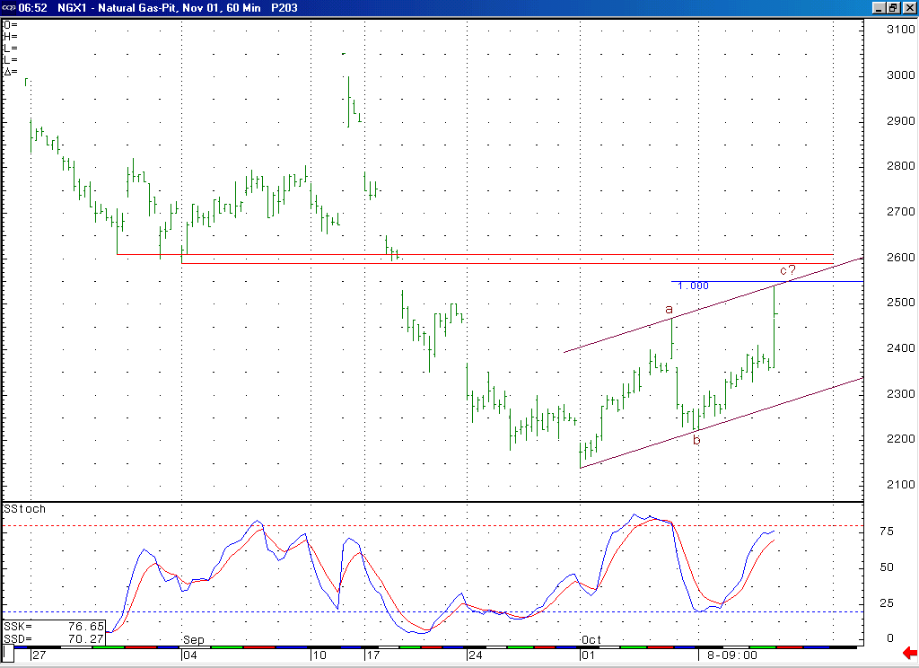
If the market were to soon turn lower, as appears likely, then it would create a bearish momentum divergence here in this 14-bar stochastic.
The market should have very stiff short-term resistance here in the 2.55 to 2.61 range. If it is going to leave itself in a near term bearish position, then we should soon see the market turning down convincingly from this area.

Technical Discussion: We have recently discussed the possibility that the market would need one more set (the second set) of waves 4 and 5 in order to conclude its longstanding decline. If this current rise off of the 2.14 low is in fact occurring as a wave 4 corrective rally, then it should now be very late in its development. This wave 4 scenario would call for the current strength to soon end near what should be very good resistance clustered between the 2.55 area and the 2.59 to 2.61 area. If the market can soon turn down from this area in an impulsive manner, then this should indicate that the anticipated wave 5 decline has begun. This wave 5 decline would be expected to carry the market down below the recent low at 2.14 at minimum. If the market were to soon get materially above this important short-term resistance between 2.55 and 2.61, then this would open the door to the potential of quite a bit of upward follow through in the weeks that follow.

The information herein is believed to be reliable, however Capstone Trading Advisors Inc. does not warrant its completeness or accuracy. The opinions and estimates contained constitute our judgment and are subject to change without notice. Past performance is not indicative of future results. The information contained herein is not intended as an offer or solicitation for the purchase or sale of any financial instrument or commodities. Chart provided with permission from CQG Inc.

