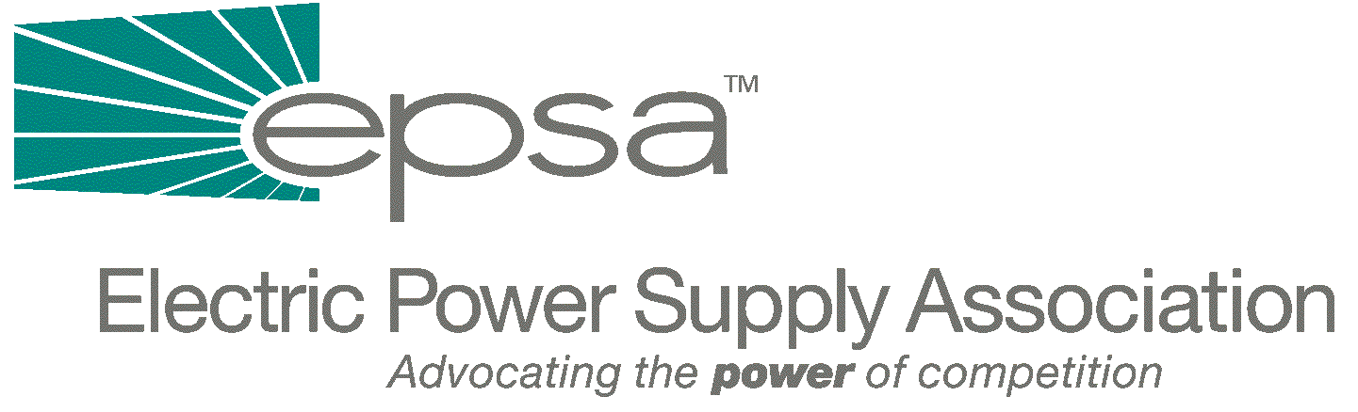

1401 New York Avenue, NW
11th Floor
Washington, DC 20005
202/628-8200
202/628-8260 fax
www.epsa.org

Memorandum
TO: | EPSA Legislative Affairs Committee
FROM: | Scott A. Weiner, Legislative Affairs Committee Chair  Donn J. Salvosa, Manager of Government Affairs
DATE: | September 28, 2025
RE: | House Subcommittee on Energy and Air Quality Hearings on Electricity

On Wednesday, the House Subcommittee on Energy and Air Quality, chaired by Rep. Joe Barton (R-TX), held two electricity hearings. The first hearing focused on reliability and transmission siting and incentives. The second hearing addressed RTOs and Federal jurisdiction. Both hearings were originally scheduled during the week of the terrorist strikes and were subsequently postponed and rescheduled for this week. Jim Steffes, Vice President of Government Affairs for Enron, presented testimony on behalf of EPSA at the first hearing. Peter Esposito, Vice President & Regulatory Counsel for Dynegy, presented testimony at the second hearing.
Only a few members from the Subcommittee were present throughout the hearings. During opening statements, Chairman Barton presented an outline of the latest electricity draft which he circulated to members this week (EPSA e-mailed this draft to our Legislative Affairs Committee on Tuesday). The goals of the legislation are to increase supply and transmission capacity by addressing siting, RTO development, reliability and jurisdictional issues. A common theme echoed by members at the hearing was the need to improve the transmission infrastructure to address constraints and transport power to areas of high demand.
The first hearing featured testimony from a wide range of witnesses, including NARUC, EEI, public power, rural cooperatives, NERC and PJM. Although all the witnesses agreed that improving and expanding the transmission system is essential, they differed on how to address the issue. Most witnesses supported the need for Federal siting provisions with a possibility of federal eminent domain; others, such as NARUC, continued to voice their opposition. While the utilities supported incentive rates to encourage higher rates of return for new transmission, many groups (e.g., public power, the coops and ELCON) were opposed. Witnesses from NERC and public power continued to support the “consensus” reliability title, while PJM and ELCON joined Jim Steffes in emphasizing that the inevitable link between reliability standards and commercial practices requires increased FERC authority and involvement.
The second hearing focused on RTOs and Federal/State jurisdiction. The panel consisted of representatives from EEI (the Southern Company), public power, rural cooperatives and consumer advocates, along with Peter Esposito on behalf of the competitive power supply industry.
A number of members, including Reps. Charlie Norwood (R-GA), Richard Burr (R-NC) and Rick Boucher (D-VA), took the opportunity to ask pointed questions about FERC’s recent efforts to consolidate the RTOs. Many of these questions were posed to Allen Franklin, Southern Company’s CEO. Franklin used this opportunity to criticize FERC and to outline for the Subcommittee a number of reasons why the recent FERC RTO Order was counterproductive and lacked needed support from the states.
Mr. Esposito voiced his support for large RTOs, calling FERC’s actions necessary to reduce the problems associated with RTO “seams” and to allow appropriate regional markets to develop. He further argued for the need to promote access to the markets through uniform interconnection rules and greater certainty in the regulatory environment. Joining in support for FERC’s actions on larger RTOs were Marc Gerken from American Municipal Power in Ohio and Michael Travieso representing NASUCA.
At the end of the hearing, Chairman Barton announced that he would hold no more electricity hearings with the possible exception of a legislative hearing on the final draft bill. He asked for comments from industry groups on his most recent draft, and he expects to circulate a third draft within the next few weeks. He plans to schedule a markup if and when the Senate reports out energy legislation.
We will continue to keep you posted on developments as they arise. We will also circulate the Subcommittee’s third draft, if and when it becomes available. If you have any questions, please contact Gene Peters(gpeters@epsa.org) or Donn Salvosa (dsalvosa@epsa.org).

