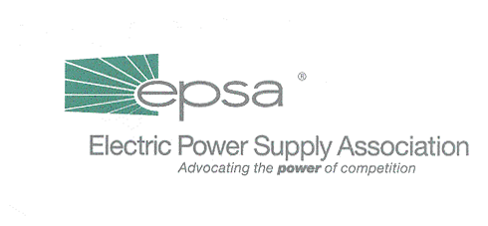
1401 New York Avenue, NW
11th Floor
Washington, DC 20005
202/628-8200
202/628-8260 fax
www.epsa.org
Memorandum
TO: | Legislative Affairs Committee
FROM: | Scott Weiner, Legislative Affairs Committee Chair  Gene Peters, Vice President of Legislative Affairs
DATE: | October 10, 2001
RE: | Senate Energy and Natural Resources Committee Cancels Markup of Security Legislation

It appears that the Senate Energy and Natural Resource Committee is done with energy legislation for the year. After an unsuccessful effort to negotiate a limited "energy security infrastructure" bill, Committee Chairman Jeff Bingaman (D-NM) pulled the plug on a markup that had been scheduled for today. In a move coordinated with Majority Leader Tom Daschle (D-SD), Bingaman also indicated that there would be no Committee markup of comprehensive energy legislation this year. Instead, the Committee staff, working with the Leadership, will draft a proposal that will be taken directly to the Senate floor before year-end, with no further action by the Energy and Natural Resources Committee.

Much of this shift can be attributed to well-founded concerns that any energy legislation moving through the Committee will be unable to avoid a successful amendment that permits the Arctic National Wildlife Refuge (ANWR) to be opened for development. Now, any such amendment will have to be adopted on the Senate floor, where it will surely be filibustered. If the filibuster is successful (still a good bet), the ANWR amendment will fail and Democrats will be able to vote in favor of comprehensive energy package. If the filibuster fails, the bill will become mired in divisive debate, and Daschle will "reluctantly" withdraw it from further consideration. We are monitoring the situation and will inform the EPSA Legislative Affairs Committee once we have more information.

