Capstone Trading Advisors Inc. 830-249-7007

Nat Gas Summary for 10/10/01: If the market was going to maintain its best chances for moving lower in the near term, then we had wanted to see it be held in check by the resistance in the 2.375 area. The market slightly and briefly poked above this area yesterday afternoon. Therefore if it is going to turn down from this area as anticipated, then we will need to see it get moving lower right out of the gate this morning. If it can accomplish this, then its initial downside target should be its last swing low at 2.22, and then last weeks low at 2.14. If the market moves materially above this short-term resistance in the 2.375 area (especially if it does this after digesting this weeks AGA number), then this opens the door for a challenge of the recent high at 2.47, and the possibility of a move up into the lower 2.50’s. However, if this were to occur, then we would expect the market to again face very stiff short-term resistance in this area.

Support: 2.35 2.31 2.255 2.22 2.14 Resistance: 2.415 2.47 2.50-2.53 2.55

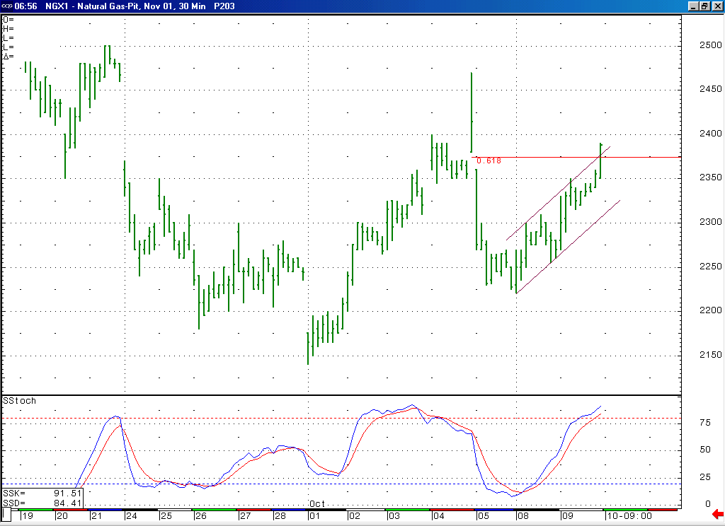
The market briefly and slightly overshot the resistance here in the 2.375 area yesterday. If we are going to continue to view this rise off of the 2.22 low as a minor degree correction, then we will ideally need to see the market turn lower from this area quite soon.
The fact that the market is currently in a near term overbought position would support the idea of it turning lower in this timeframe.

Technical Discussion: The recent move down off of the 2.47 high very much appeared to us to be impulsive in nature. If this is the case, then this would cause us to expect the current rise off of the 2.22 low to occur as a minor degree correction. If this is the case, then we had expected this rise to ideally conclude near the short-term resistance in the 2.375 area. If the market can soon turn down forcefully from this area, then it should set its sights on moving down below 2.22 and then 2.14 in an impulsive manner. If the market instead were to now get materially above this 2.375 resistance, then this would open the door to some possibilities that would allow for it to move a little bit higher in the near term. Even under such circumstances we would expect the market to again encounter a great deal of short-term resistance, clustered between the high 2.40’s and the high 2.50’s. If the market is in fact going to move somewhat higher in the near term, then we would have to view the impulsive move down off of the 2.47 high as occurring as the wave C of a downward expanded flat correction (although it would certainly not be a textbook example of one).

The information herein is believed to be reliable, however Capstone Trading Advisors Inc. does not warrant its completeness or accuracy. The opinions and estimates contained constitute our judgment and are subject to change without notice. Past performance is not indicative of future results. The information contained herein is not intended as an offer or solicitation for the purchase or sale of any financial instrument or commodities. Chart provided with permission from CQG Inc.

