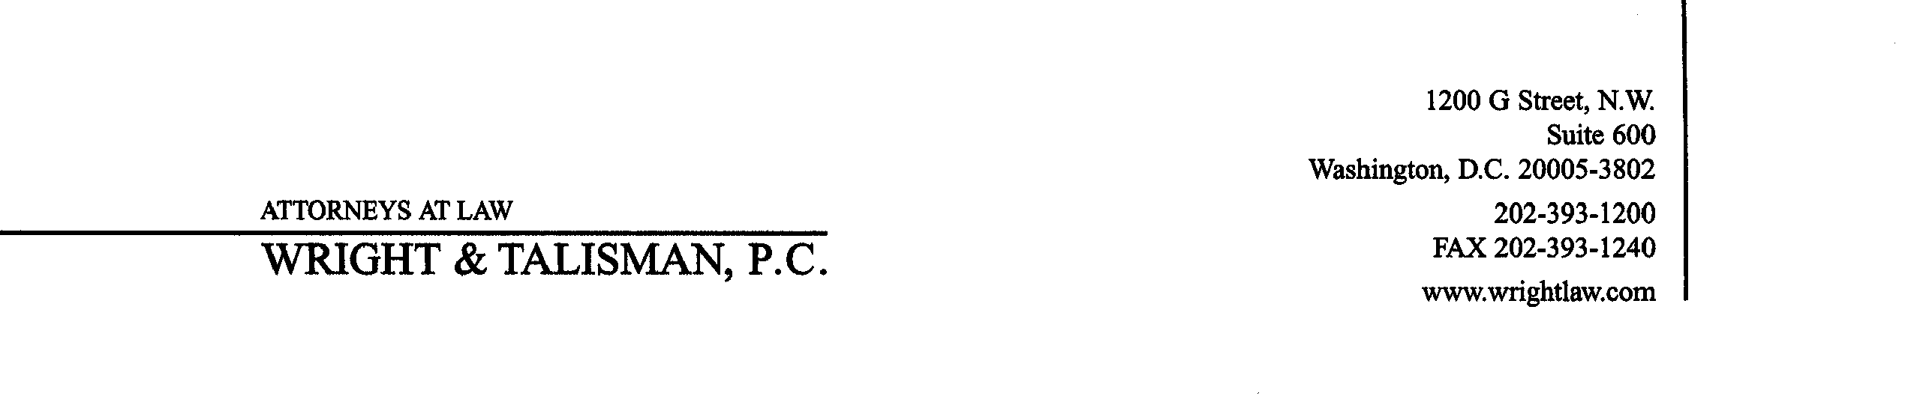
Michael E. Small
small@wrightlaw.com

September 27, 2001

To: WSPP Executive Committee
WSPP Contracting Committee and Credit Contacts

From: Mike Small

Re: November meetings

On November 1, 2001, we will have a meeting from 12:00 p.m. – 4:00 p.m. to discuss collateral/margin and umbrella netting agreements. Please let me know if you want to make a presentation and/or if you have any documents to circulate.

On November 2, 2001, we will have an Executive Committee meeting to vote on contract changes which come out of the October Operating Committee meeting as well as other matters to be detailed in a future agenda.

The meetings will be held at:

Coronado Island Marriott Resort
2000 Second Street
Coronado, California 92118
(619) 435-3000
(619) 435-4183 – fax

It is within about 10 minutes of the San Diego airport.

Please RSVP to my secretary Winnie Howard (Howard@wrightlaw.com) and please specify which meeting you will be attending.

wspp/1003-542-147

