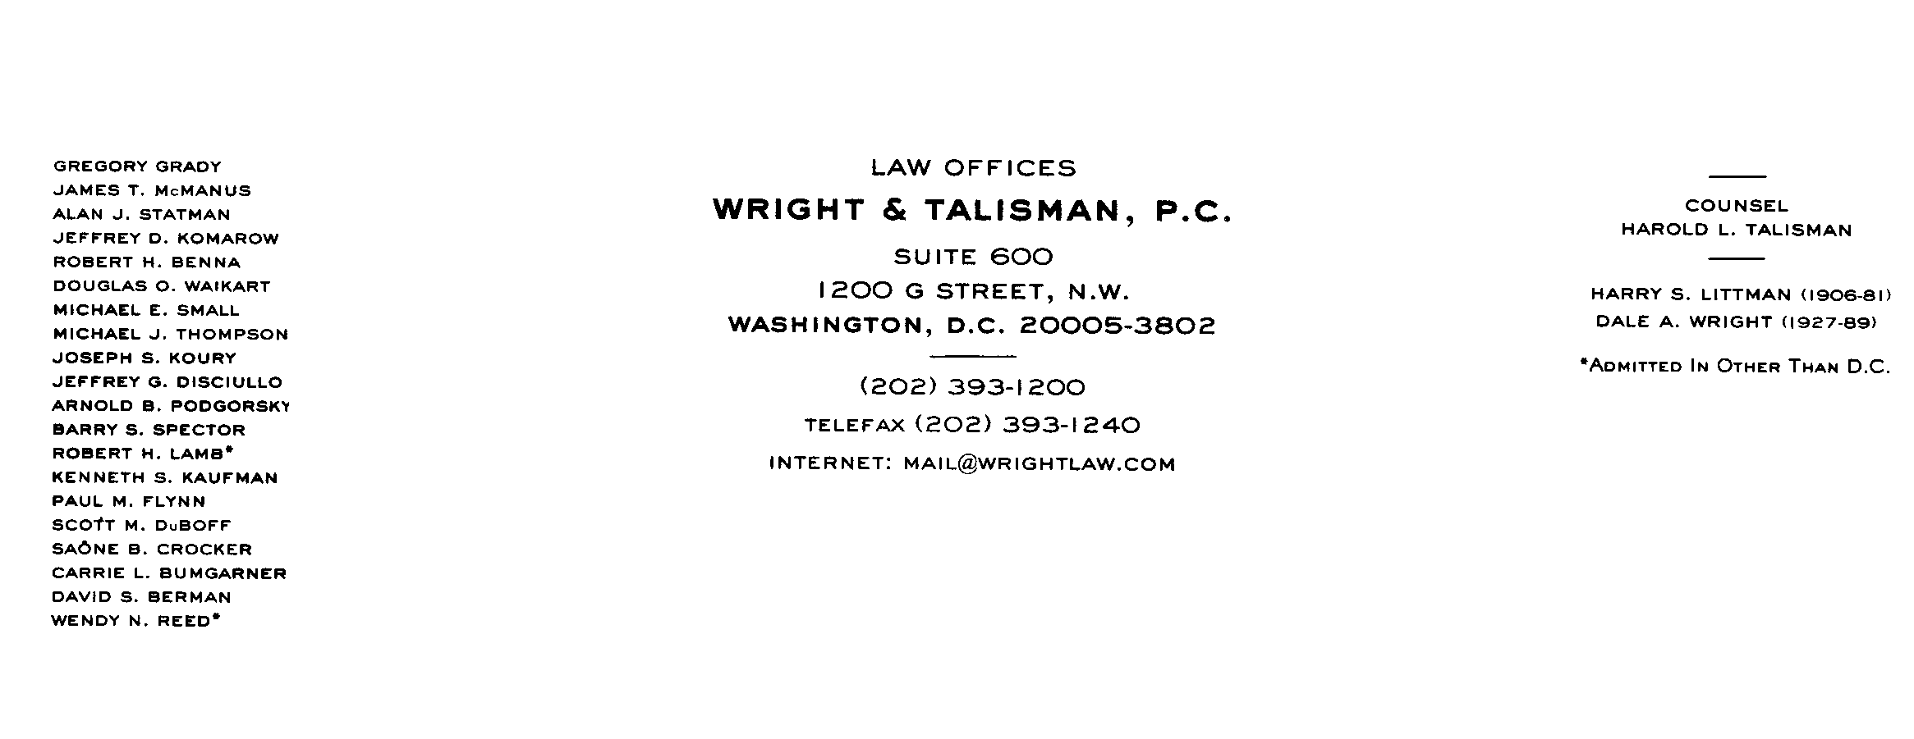
MEMORANDUM

To: WSPP Contracting Attendees

From: Michael E. Small, General Counsel to Western Systems Power Pool

Date: August 11, 1999

Re: Revisions to WSPP Agreement

As I currently do not have a red-lined version, I have had a memo prepared detailing the proposed changes to the WSPP Agreement. Attached is that memorandum.

cc: Jim Kenney
Beth Bowman
Ricky Bittle

wspp\1003-416-147

