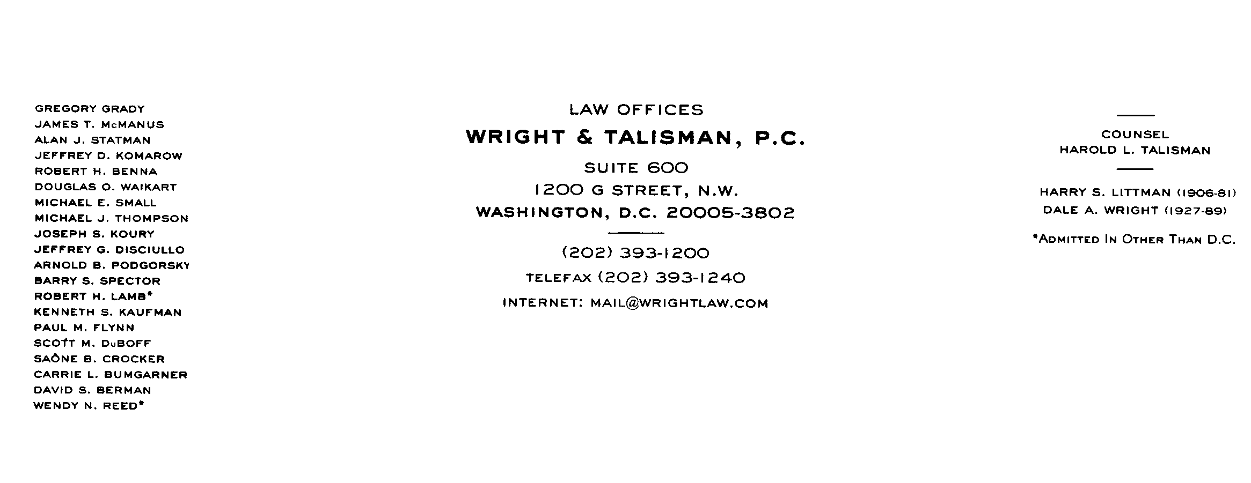
MEMORANDUM

To: WSPP Contracting Group

From: Michael E. Small, General Counsel to Western Systems Power Pool

Date: August 10, 1999

Re: Latest draft of revisions to WSPP Agreement for August 20, 1999 meeting at the
Marriott, Denver Airport

Enclosed is the latest draft of the WSPP Agreement including proposed changes. Unfortunately, we are having difficulty producing a red-lined version; therefore, only the Service Schedules show the changes. I hope within the next day or two that this problem will be fixed. At that time, I will send out a red-lined version.

The principal changes involve: (1) additions to Service Schedule C to better define what is a Firm Product and related changes; (2) language specifically allowing options (mostly in the definitions and confirmation); (3) the inclusion of clarifying definitions (i.e. letter of credit, guarantee agreement, and guarantor); (4) language in Section 21.3 allowing penalties to be recovered as part of damages for non-performance and clarification that such damages also include the costs of purchasing reserves to cover Seller’s failure to provide the necessary reserves; (5) the addition of language (§ 37) binding parties to amendments and grandfathering old transactions under the prior version if the agreement is modified; (6) the reordering of the pricing provisions in the service schedules and imposing an obligation on the Seller to state if it does not the have authority to charge market rates; and (7) the addition of dispute resolution and mediation procedures.

At the August 20 meeting, we will give these additions a final review. There also are a number of issues to discuss, including the following:

1. Whether the language in Section 21.1 eliminating the waiver of consequential and other types of damages for intentional and other types of acts should be removed.

2. Whether additional changes to the damage and liquidation calculation provisions need to be added to reflect the addition of options.

3. Whether audit provisions which keep open a bill for one year should be added.

4. Whether penalties should be expressly included in the definition of costs as used in determining the liquidation amounts.

If we have time, we can discuss the implications of Cinergy’s recent actions. For example, do we need to better define what due diligence requires in a force majeure context?

The meeting to discuss these changes will be at the Denver Airport Marriott (303-371-4333). The meeting will begin at 10:00 a.m. and should be finished by 2:30 p.m. Please let my secretary know if you are attending (Howard@wrightlaw.com).

cc: Jim Kenney
Beth Bowman
Ricky Bittle

wspp\1003-415-147

