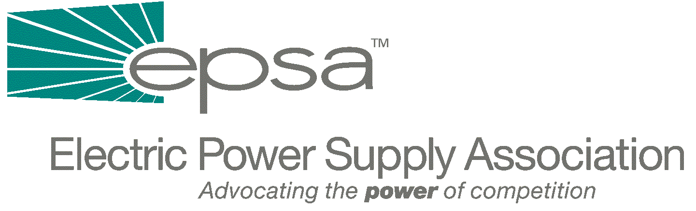

1401 New York Avenue
11th Floor
Washington, DC 20005
202/628-8200
202/628-8260 fax
Memorandum
TO: | Legislative Affairs Committee
FROM: | Scott A. Weiner, Legislative Affairs Committee Chair  Donn J. Salvosa, Manager of Government Affairs
DATE: | September 21, 2001
RE: | House Subcommittee on Energy and Air Quality Hearing on Federal Perspectives on Electricity Restructuring

On Thursday, the House Subcommittee on Energy and Air Quality, chaired by Rep. Joe Barton (R-TX), held a hearing on Federal Perspectives to Electricity Restructuring. Witnesses included Deputy Secretary of Energy Francis Blake and all four FERC Commissioners.

Opening statements from most Members conveyed their concerns over the safety of the nation’s energy infrastructure, including power plants, pipelines and transmission lines. Other Members indicated a need to improve and increase transmission infrastructure and energy supplies in order to maintain reliability. When the FERC Commissioners testified, a number of Members also requested an explanation of FERC’s July Order calling for the consolidation of RTOs.

DOE Deputy Secretary Francis Blake stated that the Administration advocated an electricity component as part of a broad energy bill. His comments also reflected the concerns of many Members about the need for an increase in transmission and generation infrastructure in order to create a reliable and competitive market.

Each of the FERC Commissioners stated their support for the development of new transmission infrastructure with FERC jurisdiction over interstate transmission lines. Chairman Pat Wood discussed the need for a clear set of rules governing the transmission system and the need for investment incentives to build infrastructure. Commissioner Linda Breathitt stated her support for the development of RTOs, a clear set of interconnection rules for generation, federal eminent domain authority and mandatory reliability rules. Commissioner Nora Brownell joined Breathitt and Commissioner William Massey in emphasizing a need for the development of new generation through clear interconnection rules. Brownell also shared Wood’s and Massey’s assertion that FERC needs clear authority to address unjust market actions.

In response to Chairman Barton’s question on the FERC Order to move towards four RTOs, Chairman Wood emphasized that RTO consolidation would help alleviate the high economic costs associated with reliability and seams issues, among other things. Having 10 to 12 RTOs, as might develop absent FERC intervention, would merely be a waste of consumer dollars. Chairman Barton stated that the Subcommittee’s draft language would set a time limit for joining an RTO.

Questions also arose on the pending court decision involving transmission jurisdiction. Chairman Wood and Commissioner Brownell agreed that legislative language should be passed giving FERC full authority, adding that Congress should not wait for the courts to decide. Commissioner Breathitt took a different view, saying that Congress could wait to see how the courts rule.

Chairman Barton asked Chairman Wood whether or not FERC needs more flexibility on reliability language. Wood answered that the world has changed dramatically from two years ago when the NERC language was crafted, and FERC or its designee should be given the power to enforce reliability. Brownell stated that the role of RTOs have changed. She agreed with Massey that reliability has commercial impacts and should be addressed by FERC.

At the conclusion of the hearing, Chairman Barton said that – given the possibility that Congress will adjourn in mid-October – the probability of passing legislation through Congress and getting it to the President’s desk is slim. However, he directly asked Chairman Wood to determine if the President wanted the Congress to include an electricity title in a broad energy bill. If the Administration endorses electricity legislation, Barton pledged to work towards passing an electricity title for approval by the President in mid-October.

The Subcommittee’s draft legislation is scheduled to be circulated sometime next week. As soon as we receive copies, we will forward them to you. In the meantime, if you have any questions, please contact Donn Salvosa (202-628-800 or dsalvosa@epsa.org).

