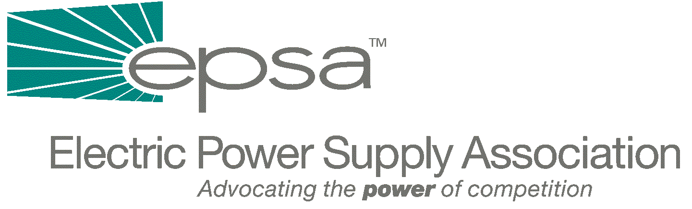

1401 New York Avenue
11th Floor
Washington, DC 20005
202/628-8200
202/628-8260 fax
Memorandum
TO: | EPSA Legislative Affairs Committee
FROM: | Scott A. Weiner, Legislative Affairs Committee Chair  Andrea L. Spring, Manager of Government Affairs
DATE: | September 28, 2025
RE: | Bingaman Electricity Legislation  Administration Draft Electricity Plan

We are working on an analysis of the legislation which Senate Energy and Natural Resources Committee Chairman Jeff Bingaman (D-NM) intends to begin marking up on September 13th. It’s quite complicated, and there’s a lot of new language, so we’re taking a little additional time to review it. We will distribute the bill analysis on Monday. We have attached a copy of the legislative language which pertains to electricity, as well as the committee summary of the bill.
A few provisions of interest:
- Clarifies that FERC has authority over the transmission component of electricity sold at retail.
- Allows FERC to order transmitting utilities into rtos to “remedy undue discrimination or anti-competitive effects” and allows FERC to mandate the minimum characteristics and functions of RTOs
- Gives FERC increased merger authority, including authority over generation-only mergers.
- Gives FERC increased market power authority, defining market power as the ability to profitably maintain prices above just and reasonable levels for a significant period of time. FERC can direct utilities or generators to submit plans to mitigate market power, approve or modify plans, and force divestiture.
- Makes refunds of unjust or unreasonable rates effective from the date that a complaint is filed, or from the date that FERC initiates the proceeding, instead of the current 60 days after filing.

We have also attached a copy of the major elements in the Administration’s draft electricity plan – this is a version which is being circulated on the Hill.

