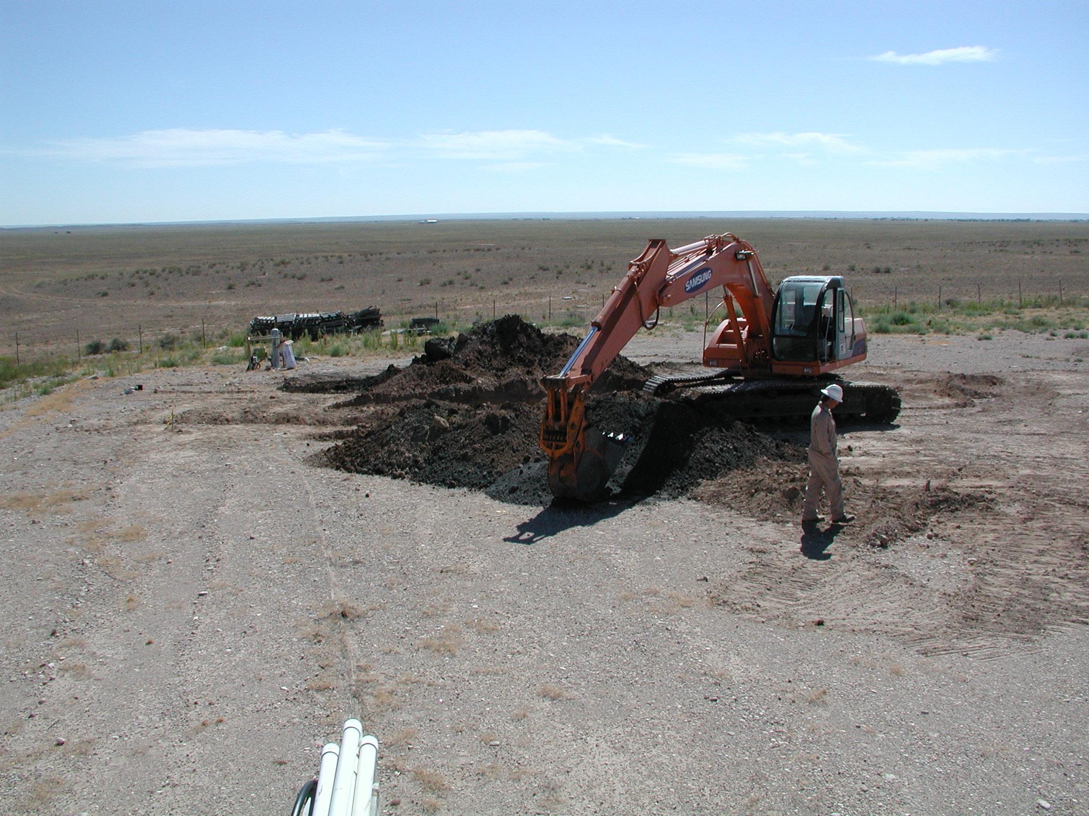
Excavating trench #3 in the former Pit #2 area.

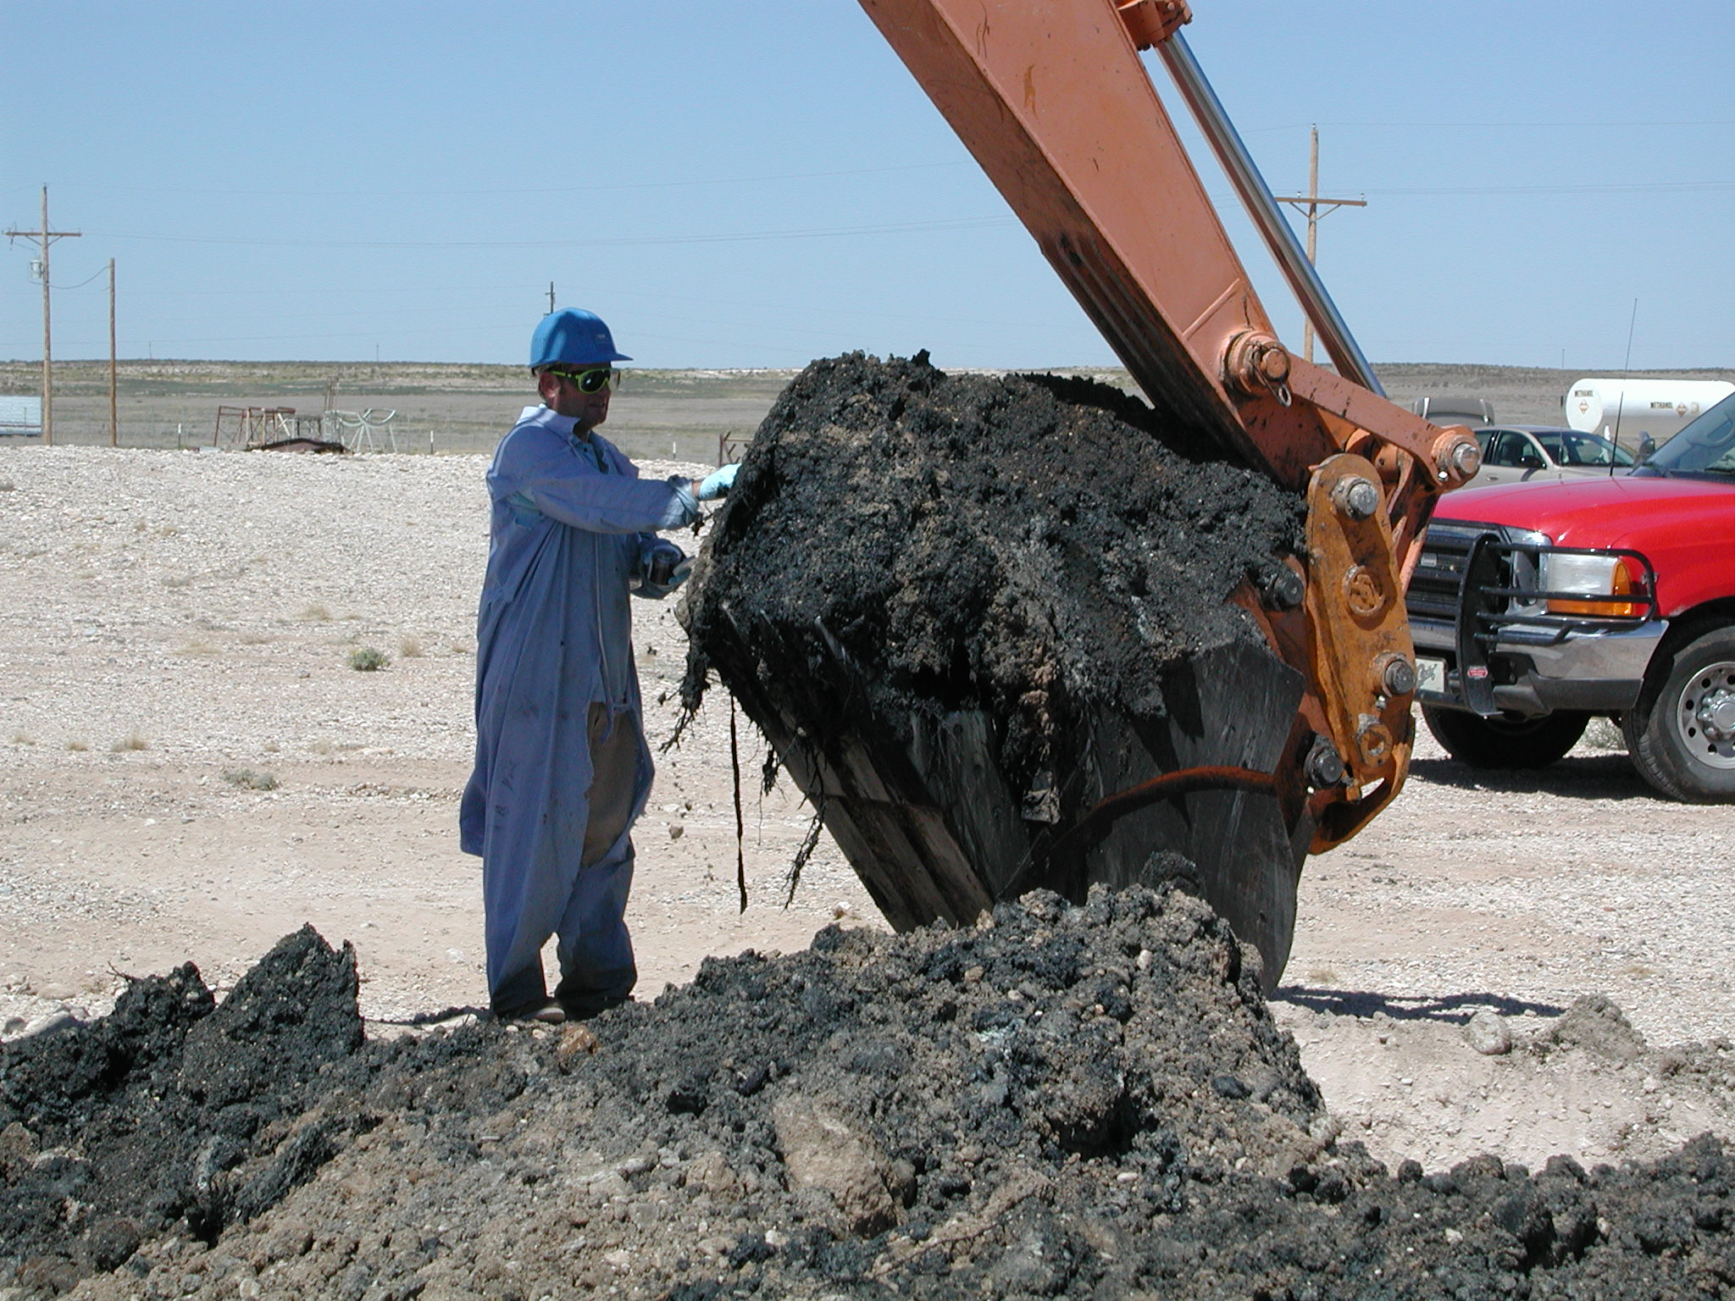
Collecting a sample for lab analysis from a trench in the Pit #1 area.

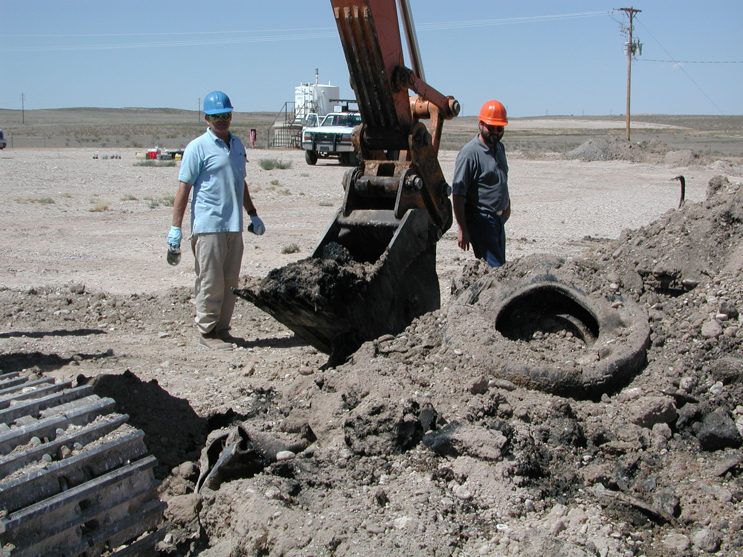
Collecting a sample for lab analysis from a trench in the Pit #1 area.

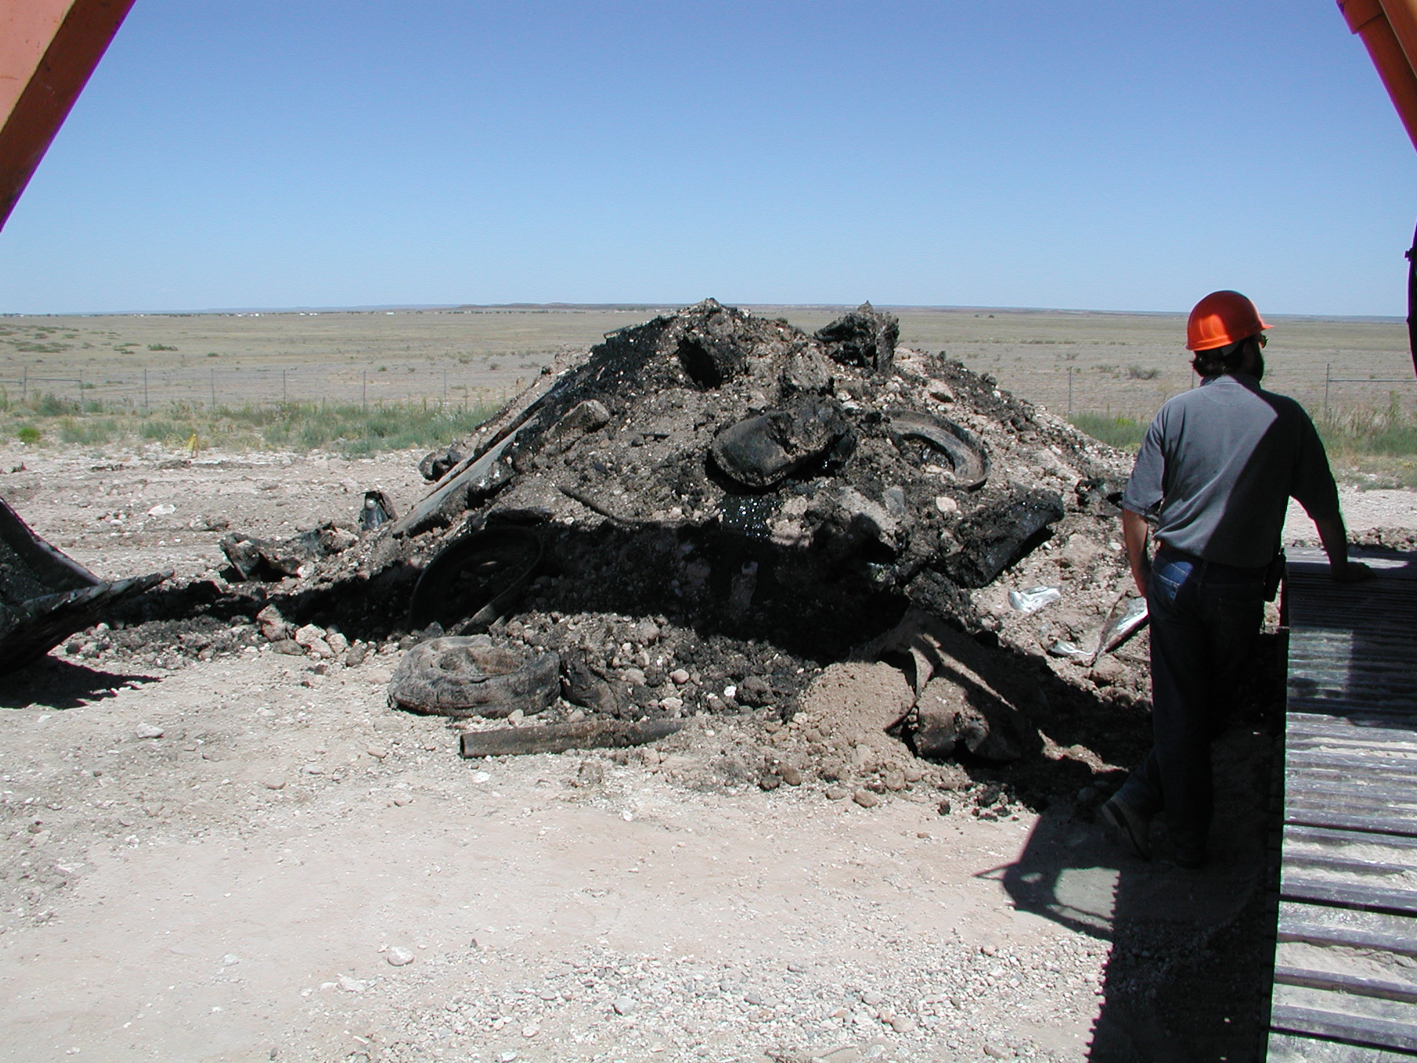
Soil and debris excavated from the east trench in the former Pit #1 area.

