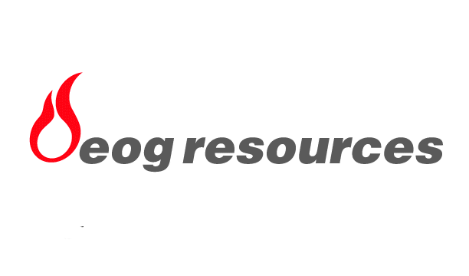
EOG Resources, Inc.P.O. Box 4362Houston, TX 77210-4362

News Release
For Further Information Contact:
Maire A. Baldwin
(713) 651-6EOG (651-6364)

EOG RESOURCES REPORTS OVER SEVEN PERCENT INCREASE
IN U.S. NATURAL GAS PRODUCTION AND
RECORD FIRST QUARTER NET INCOME AVAILABLE
TO COMMON OF $212.5 MILLION OR $1.79 PER SHARE

FOR IMMEDIATE RELEASE: Monday, April 23, 2001
HOUSTON – EOG Resources, Inc. (EOG), an S&P 500 Index company, today reported record first quarter net income available to common of $212.5 million, or $1.79 per share compared to net income available to common of $38.8 million, or $.33 per share in the first quarter a year ago.
“At a time when the industry as a whole is struggling to maintain flat gas production, EOG increased U.S. natural gas production by over seven percent. This demonstrates our ability to continue to grow our production organically,” said Mark G. Papa, chairman and chief executive officer. “Our operations and drilling inventory are in the best shape ever; we are off to a great start in 2001.”
Versus the same quarter a year ago, EOG’s North American daily natural gas production increased 4.2 percent, crude and condensate production increased 7.4 percent and natural gas liquids production decreased 31.4 percent. This resulted in overall EOG North American production growth of approximately four percent, consistent with the 2001 full year target. Based on shares outstanding, production per share increased approximately five percent in North America.
“EOG has significantly ramped up its North American activity,” Papa noted. “Over the last year, our acreage position (including trades) has increased over 50 percent, our geological and geophysical headcount has grown by over 20 percent and EOG currently has 50 percent more rigs drilling than this time last year. To position EOG for the future, North American capital expenditures increased during the first quarter to $185.0 million, compared to $85.3 million in the first quarter 2000.”
Results from the quarter further solidify EOG’s focus on organic growth and its long- term financial strategy. EOG continued to strengthen its financial structure with the following:
- Reduced the number of common shares outstanding by approximately 700,000 to 116.2 million,
- Paid down $214.1 million of debt, reducing the debt to total capitalization ratio from 38.3 percent at year end 2000 to 29.6 percent at the end of the first quarter 2001 and
- Increased the annual common dividend by 14 percent from $.14 to $.16 per share.
EOG’s first quarter conference call will be available via live audio webcast at 9:30 a.m. Central Time (10:30 a.m. Eastern Time) on Monday, April 23, 2001. To listen to this webcast, log on to www.eogresources.com. The webcast will be archived on EOG’s website for 14 days.
EOG Resources, Inc. is one of the largest independent (non-integrated) oil and gas companies in the United States and is the operator of substantial proved reserves in the U.S., Canada and offshore Trinidad. EOG Resources, Inc. is listed on the New York Stock Exchange and is traded under the ticker symbol “EOG.”

This press release includes forward looking statements within the meaning of Section 27A of the Securities Act of 1933 and Section 21E of the Securities Exchange Act of 1934. Although EOG believes that its expectations are based on reasonable assumptions, it can give no assurance that such expectations will be achieved. Important factors that could cause actual results to differ materially from those in the forward looking statements herein include, but are not limited to, the timing and extent of changes in reserve quantities and commodity prices for crude oil, natural gas and related products and interest rates, the extent of EOG’s success in discovering, developing, producing and marketing reserves and in acquiring oil and gas properties, uncertainties and changes associated with international projects and operations including reserve estimates, markets, contract terms, construction, financing availability, operating costs, and political developments around the world, and conditions of the capital and equity markets during the periods covered by the forward looking statements.

