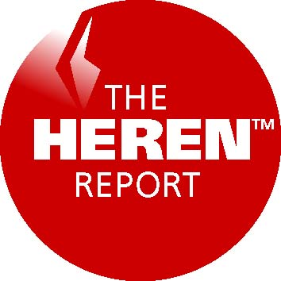
Rahil Jafry
Published by PH Energy
producers of on-line reports
and specialist international
energy information including:

European Gas Markets
British Spot Gas Markets
European Daily Electricity Markets
European Electricity Markets
The Heren Index
PH Energy Analysis Ltd
Ingram House
13-15 John Adam Street
London WC2N 6LD
United Kingdom

Tel: +44 207 839 1588
Fax: +44 207 839 1688

Web: www.heren.com
Email: patrick@heren.com

Incorporated in England & Wales
Number 2829679
VAT reg number GB 629 3055 38
Registered office:
39a Welbeck Street, London W1M 7HF
Directors:
Patrick Heren, Fiona Cadwallader
Enron Corp, 1400 Smith Street
Houston, TX 77002-7361
USA

19th April 2000

PRIVATE AND CONFIDENTIAL

Dear Rahil,
Here are our revised draft terms for posting PH Energy market coverage of European gas and power on EnronOnline.
PH Energy will post daily on the EnronOnline website the following elements drawn from our daily publications European Spot Gas Markets (ESGM) and European Daily Electricity Markets (EDEM):
- All news stories and analytical pieces from ESGM and EDEM.
- Graphs of NBP traded volumes, Heren Index values and volumes, and day-ahead power prices for all of Europe.
- Daily Heren Indices for gas and power.
- We would also require a link through to our own website.
For a non-exclusive service, EnronOnline would pay PH Energy a flat fee of $120,000, ex-VAT.
For an exclusive service, EnronOnline would pay PH Energy a flat fee of $ 140,000, ex-VAT.
Term: one year, with automatic renewal for a second year, adjusted for UK PPI. "PPI means the producer price index, as published by the Central Statistical Office in the "Monthly Digest of Statistics" under the heading "Index Number of Producer Prices - Price Index Number of Output - Home Sales - Output of Manufactured Products (DZCV)" where 1995 equals 100.
.
My contacts over the next week are as follows:
Home email: patrick.heren@virgin.net
Home telephones: +44 1227 713918 or 710470
Mobile: +44 7771 901608
If for any reason you can’t contact me next week, please speak to Richard Frape, managing editor, in our London office.
Best regards

Patrick Heren

