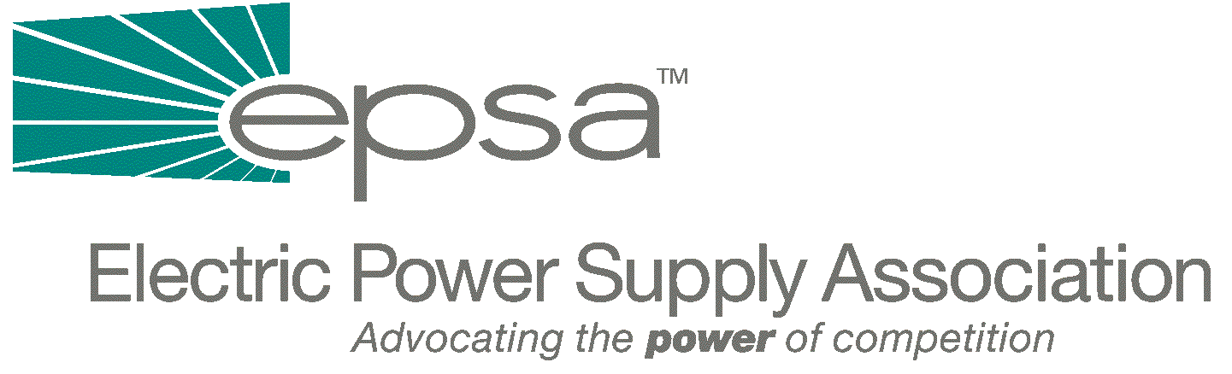

1401 H Street, NW
Suite 760
Washington, DC 20005
202/789-7200
202/789-7201 fax
www.epsa.org

Memorandum
TO: | EPSA Legislative Affairs Committee
FROM: | Scott A. Weiner, Legislative Affairs Committee Chair  Donn J. Salvosa, Manager of Government Affairs
DATE: | September 28, 2025
RE: | House Subcommittee Hearing on California’s Electricity Market  - Congressional Members Testify

On Tuesday, March 6th, the House Subcommittee on Energy and Air Quality chaired by Rep. Joe Barton (R-TX) heard testimony from Congressional Members on electricity markets in California and the western region as well as national energy policy. The witness list involved 25 members of the House, most of whom do not serve on the House Energy and Commerce Committee.

The hearing began with Subcommittee Member opening statements that in many cases repeated themes from the statements made in past hearings. Full Committee Chairman W.J. “Billy” Tauzin (R-LA) pleaded with Congressional witnesses to allow the markets to work and to take actions which promote the development of more generation in California. Rep. Henry Waxman (D-CA) countered that a competitive market in California does not currently exist and Congress cannot have blind faith in the ability of market forces to bring about lower prices. Rep. Ed Whitfield (R-KY) blamed part of the problem on the political refusal to raise retail rates in California. Other members such as Rep. John Shimkus (R-IL) argued that a competitive market requires a diversification of fuel supplies used to produce power.

A large majority of Congressional witnesses hailed from California and the Pacific Northwest. Predictably, many pleaded for a return to cost-based rates and price caps. Unsubstantiated allegations of market power abuse were common. Reflecting these positions were Reps. Mike Thompson (D-CA), Bob Filner (D-CA), Susan Davis (D-CA) and Jay Inslee (D-WA). As he did during the Energy Subcommittee field hearing held in San Diego last September, Rep. Filner denounced generators in the harshest terms, stating that “the energy cartel has been bleeding the state dry,” that generators have been manipulating the market, withholding power, and falsifying documents to hide any evidence of illegal activity. Rep. Inslee echoed similar remarks, saying that, of the 15,000 MW that have been out of commission in the West, about half have been due to routine maintenance or lack of additional emissions credits. He went on to charge that between 6,000 and 8,000 MW of generation has been offline without any explanation. Inslee speculated darkly that generation was being withheld to drive up prices. He announced that, along with Congressman Peter DeFazio (D-OR), he had requested the GAO to investigate the matter immediately. He further stated that a price cap that exempts new generation facilities would not discourage investment in new power plants.

Reps. Barton and Whitfield attempted to counter the strong opinions of the panelists. Chairman Barton attributed the crisis to demand outstripping supply and the fact that the power plants in California were older and in desperate need of maintenance and rehabilitation. Rep. Whitfield pointed to the recent FERC report on power plant operation that found no evidence of market manipulation.

There were some positive remarks made by the Congressional witnesses. Rep. Mary Bono (R-CA), a member of the Subcommittee, testified that any type of price control will slow the development of new generation and add to California’s supply problems. Rep. Darrell Issa (R-CA) stated that deregulation should not be blamed for California’s market collapse, because California did not fully deregulate their market. He also noted that barriers to entry have prevented new generation from being built. Rep. Greg Ganske (R-IA), another member of the Subcommittee testifying on the panel, stated that the strong NIMBY movement had contributed to the lack of new generation.

Other panelists discussed other issues related to national energy policy, the need for conservation, off-shore drilling and diversification of fuel supplies (e.g., clean coal, nuclear power) to reduce our reliance on foreign supplies. An unusual proposal was put forth by Rep. Brad Sherman (D-CA) to adjust daylight savings time to double daylight savings time during the winter. The idea would be to ensure that there would be daylight between the hours of 5:00 PM and 8:00 PM. He claimed that this would result in a 1-2% reduction in energy use since consumers can open their blinds for lighting purposes as opposed to turning on their lights in the evening.

If you have any questions, please contact Donn Salvosa, EPSA Manager of Government Affairs (202-789-7200 or dsalvosa@epsa.org).

