How to Access Stack Manager and the new UBSWenergy.com Environment

Using the Citrix Cluster:
- Access Remote Services at: http://remoteservices.netco.enron.com/
- Choose UBSWenergy Cluster from the drop down menu
- Login to the Citrix Cluster with your Corp. ID and Password
- Launch Stack Manager from the Start Menu
- Login to Stack Manager using the new UBSWenergy.com trading ID and password provided to you

With a Stand Alone UBSWenergy.com Machine:
The migration of Stand Alone machines to the UBS environment is in progress; therefore, for purposes of the Simulation please use the Citrix Cluster for access to the UBSWenergy.com environment and Stack Manager.

Access to the new website:
For the Simulation please use the following link:
http://www.ubswenergy.com/site_index.html

Basic Stack Manager Questions and Review

- What do the icons on the tool bar of Stack Manager do?

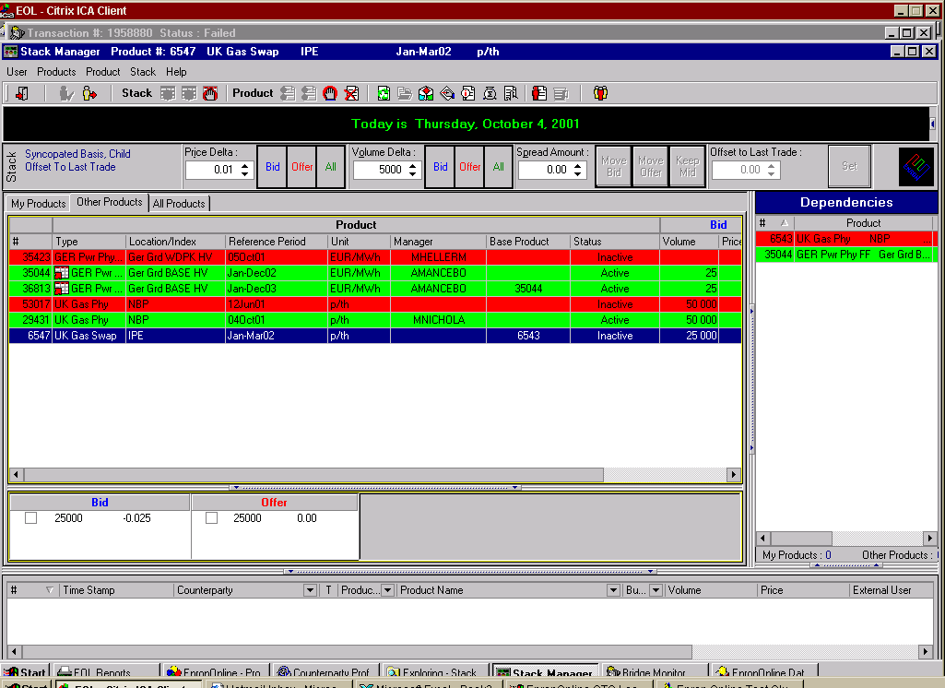
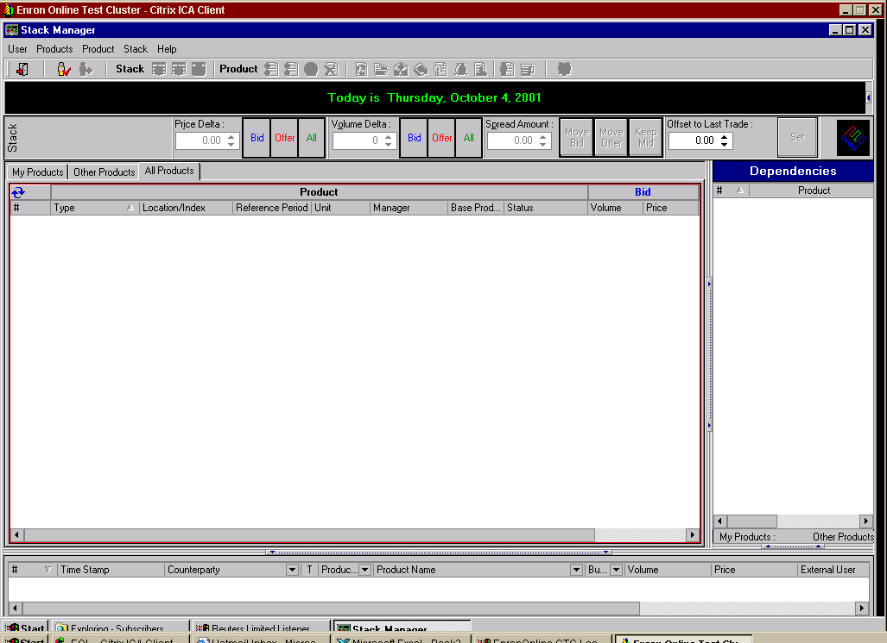
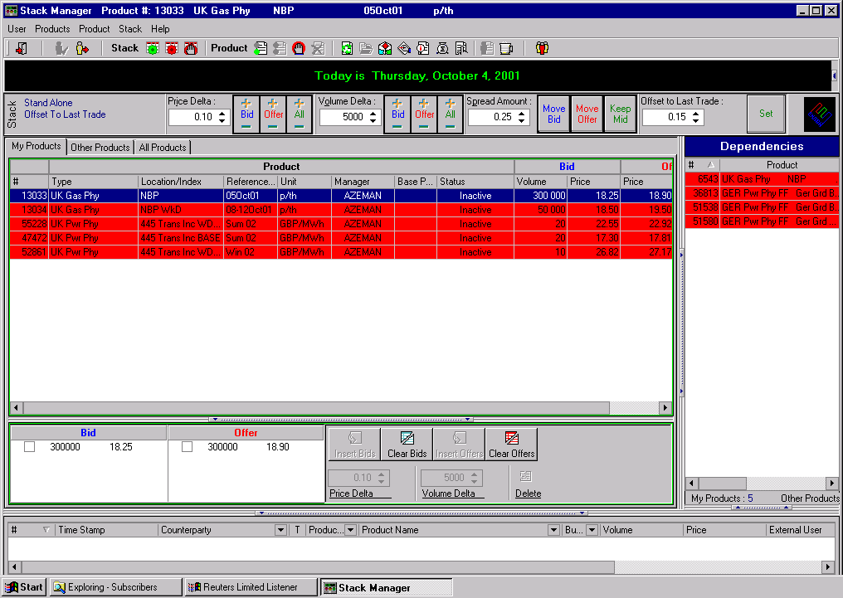
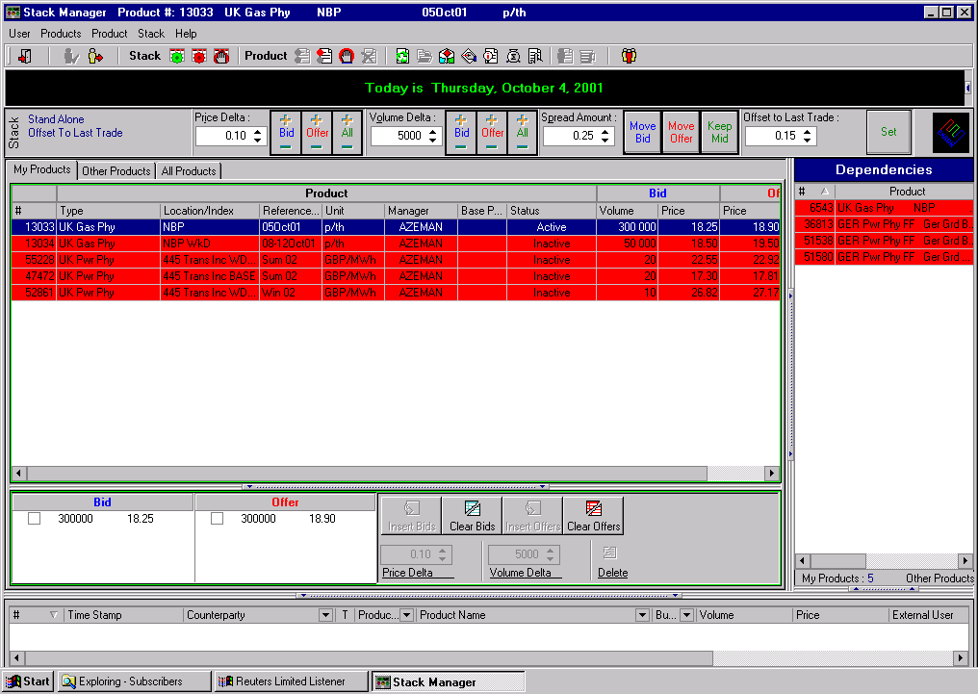
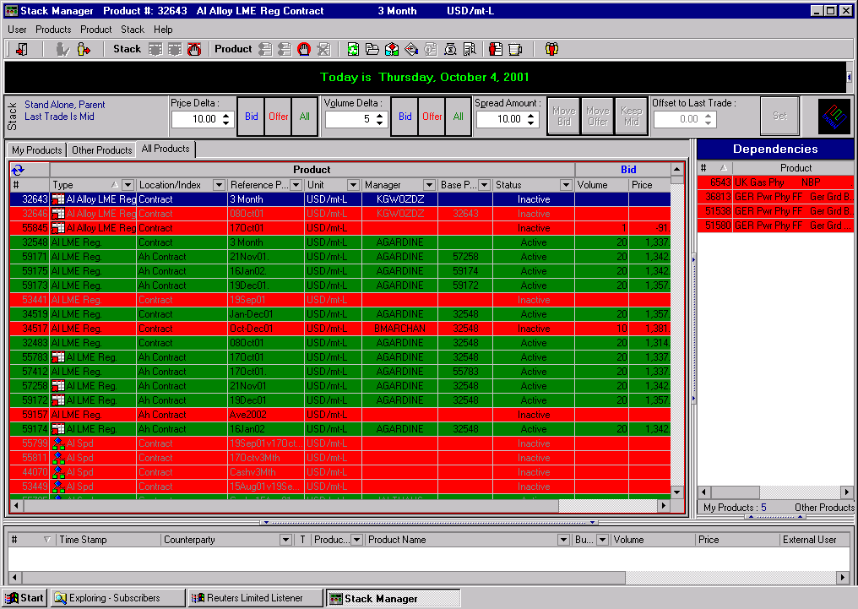
Exit
Log Off
User
Suspend
Product
Log In
User
Activate
Product
Activate
Stack
Inactivate
Stack
Inactivate
All
Suspend
All
Refresh
Remove
Product
Open
Product
Product
Properties
Product
Description
Watch
Product Stack
Show Orders
Transaction
Summary
Manage
Product
Clear
Manager ID
Show Active
Counterparties

- My Product is Active, but I can’t see my prices or volumes in Stack Manager or on the website. What’s wrong?

Your Stack Prices have become Inactive. To post prices to the website you need to: Click the green Activate Stack button, which is found on the tool bar next to the word Stack or on the right-click short cut menu.

- Why can’t I activate my product?

If your product is linked to another product, that product (the parent) must be Active in order for your product (the child) to be activated.

- I am trying to insert bids and offers and am getting error messages, why?

Open your Product Properties page and ensure that your Price and Volume Garbage Checks are set appropriately.

- I can only insert one bid and offer, what’s wrong?

Open your Product Properties page and verify your Stack Reset. If it is set to an automatic reset, either Last Trade is Mid or Offset to Last Trade, you are only allowed to enter one Bid and Offer since the system calculates the next one for you.

- Every time adjust my Bid, my Offer moves with it, why?

You have a Constant Spread Amount selected on your Product Properties. To remove this, open your Product Properties and un-check the Constant Spread Amount box.

- Can I be alerted when a trade is done?

Every trade that occurs will automatically show up in your Today’s Transactions window at the bottom of your Stack Manager. If you have stand alone speakers on your desk, you will be able to set your Stack Manager to play a sound each time a transaction or error occurs. To change the sound settings in Stack Manager, click on Help, Options, and Sounds. You will be able to increase the volume and duration of sounds on the first screen. It is also necessary to click on System Sounds on the far right side and enable system sounds by clicking in the box at the top. Click Ok when you are finished making changes.

- How will I know if someone has placed an order on one of my products?

If you are allowing orders to be placed on your products, you can click the Show Orders button on the tool bar. If you click the Stay on Top button at the top of the order window it will allow you keep the window open wherever you position it.

- How can I see my transactions from today?

Each transaction that occurs will be listed individually at the bottom of your Stack Manager in the Today’s Transactions window. You can see your overall trading activity by clicking the Transaction Summary icon on the tool bar. This will bring up a window with a summary of your trading activity by product type with weighted averages of both buys and sells for the day.

Note: If more detailed deal information is needed there are several reports available on the reporting database application in the UBSWenergy.com environment.

- How can I watch prices for products that I’m not managing?

- Open the All Products tab in Stack Manager
- Select the product(s) you are interested in watching
- Double click on the product(s) or right-click and select Open Product.
- Open the Other Products tab; the selected products will appear, and you will be able to view the product properties. Updates occur on this tab on a real time basis.

Note: Products in the Other Products tab are view only. You are not able to make any changes.

- What happens if I forget to suspend my products before going home in the evening?

Each product is set up with trading hours, which can be adjusted in the product properties page. At the time you have designated for your product’s trading hours to end, your product’s font will turn gray in Stack Manager and your prices and volumes will disappear from the website. In order to activate your prices, you will need to click the Activate Stack button next to the word Stack on the tool bar; however unless you change your trading hours in the product properties page the stack prices will automatically inactivate again. To completely take the products off the website, you will have to click the Suspend button found next to the word Product on the tool bar.

Note: If there are active Top of Stack limit orders against your product at the end of the trading hours, those Top of Stack prices will remain visible and transactable on the website.

- How do I change the colors on my products to distinguish between Active, Suspended, and Inactive?

- Click on Help at the top of the application and select Options
- You can change the product status colors, sounds, and the price and volume display controls from this screen.
- Click Ok at the bottom of the screen

- What do I do if I’ve forgotten my password?

Please send an email to one of the following individuals and we will have the password reset for you.

Stephanie Sever
Claudia Clark

- I’ve created several products in Product Manager but I can’t see them in my Stack Manager yet. What else do I need to do?

Please call a member of our Online Trading Operations group with the product id numbers. The member will review and approve your products for you.

Kevin Meredith x39555
Chris Walker x37533

If you have any further questions please feel free to contact our support desk from 7am – 7pm EST.

UBSWenergy.com Help Desk 713-584-4444

