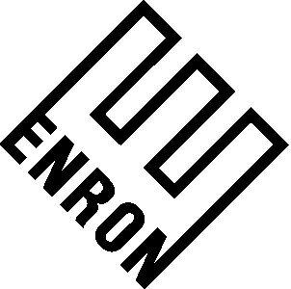

To: | Bill Rapp
From: | Jeff Hodge | Department: | ENA - Legal
Subject: | American Express Company ("American Express") | Date: | May 24, 2001

Pursuant to your request, I have reviewed the proposed Commodity Management Agreement, the ("CMA"), and the Platform Agreement between Enron Energy Services Operations, Inc. ("EESO"). My thoughts are as follows:

- All of the changes that have been made to the form agreement for initial use should be made to these agreements.

- Section 2, Item 15 of the CMA, it remains unclear to me as to what happens if a new Strike Price and Strike Term is not agreed to. I understand that it will not fit into the calculations, but I presume that EESO may still be providing the quantity formerly subject to the Strike Price. The question then is does there always need to be a strike price?

- In Section 3, Item 5 of the CMA, it appears as though EESO is the calculating agent on the Default Payment. However, Schedule G indicates that Termination Amounts are to be calculated by the Non-Defaulting Party. That needs to be fixed. Also, the CMA contemplates "one-way" payment. A decision has to be made on "one-way" versus "two-way" payment.

- I cannot find a bankruptcy event of default in either document.

I trust the foregoing meets your current needs. Should you have any questions or comments, please contact me at your convenience.

JH/ke

cc: Jim Keller
Carol St. Clair

