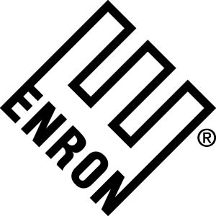 1400 Smith Street
Houston, TX 77002

November 16, 2000

Diane Nielsen
Event Resource Incorporated

RE: ENRON 2000 HOLIDAY PARTY

Dear Diane:

I received your fax dated November 13, 2000. In my letter to you dated November 8, 2000, I specifically requested a full and detailed accounting of the Enron deposit money. Your fax was very vague, to say the least, and did not include the following information which I must have immediately:

- Total amounts and copies of each ERI (Event Resource Incorporated) check written to the various vendors involved in the holiday party.
- Copies of each contract/agreement made between ERI and the various vendors involved in the holiday party.

In the June 27, 2000 meeting with Kala Sorenson (Houston Astros Director of Conference Center at Enron Field), you, others from ERI, and me, at the Enron Field, Kala specifically informed us that a detailed written event proposal needed to be submitted to her for approval no later than 30 days prior to the event. No production should have been started or money paid out to vendors until this written proposal had been submitted to and approved by the Houston Astros Management Team at Enron Field. As of Monday, November 6, 2000, no such written proposal had been submitted to either me or Enron Field. The staff at Enron Field was totally unaware that we were considering a fireworks show for the holiday party.

Since our June meeting, I have repeatedly requested from you a timeline as well as a complete, clear, and concise written concept of the party. I never received them. You have not demonstrated the necessary diligence or communication in the production of this event.

Furthermore, Enron never approved the production estimate (#97242) for fireworks, décor, centerpieces and balloon entry decor. I was surprised to see them in your faxed letter of November 13, 2000, given that Enron had not given written approval for these expenses. Let me be clear; we do not approve those items and do not expect to pay for them.

As promised in your letter of November 4, 2000, please refund the payment made in June of 2000. This amount should be a full refund of the deposit money (check #4132037830 in the amount of $248,991.40), less any money that has been committed to (with valid proof of payment) from the original signed production invoice #6250 including the items listed below:

- Chairs
- Tables
- Chair covers and sashes
- Table cloths - crushed velvet
- Table cloths - overlay platinum

Do not send any future checks to additional vendors.

This refund must arrive in my office no later than Monday, November 20, 2000. If this check is not received, this matter will be referred to our Enron attorneys.

Sincerely,
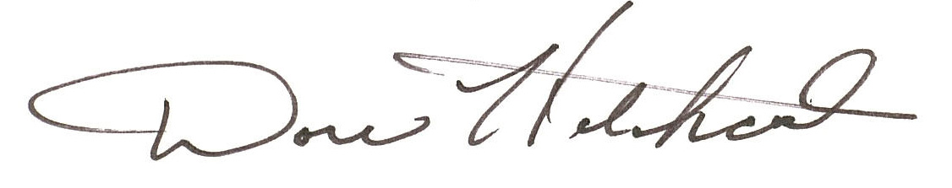

Dorie Hitchcock
Event Manager

